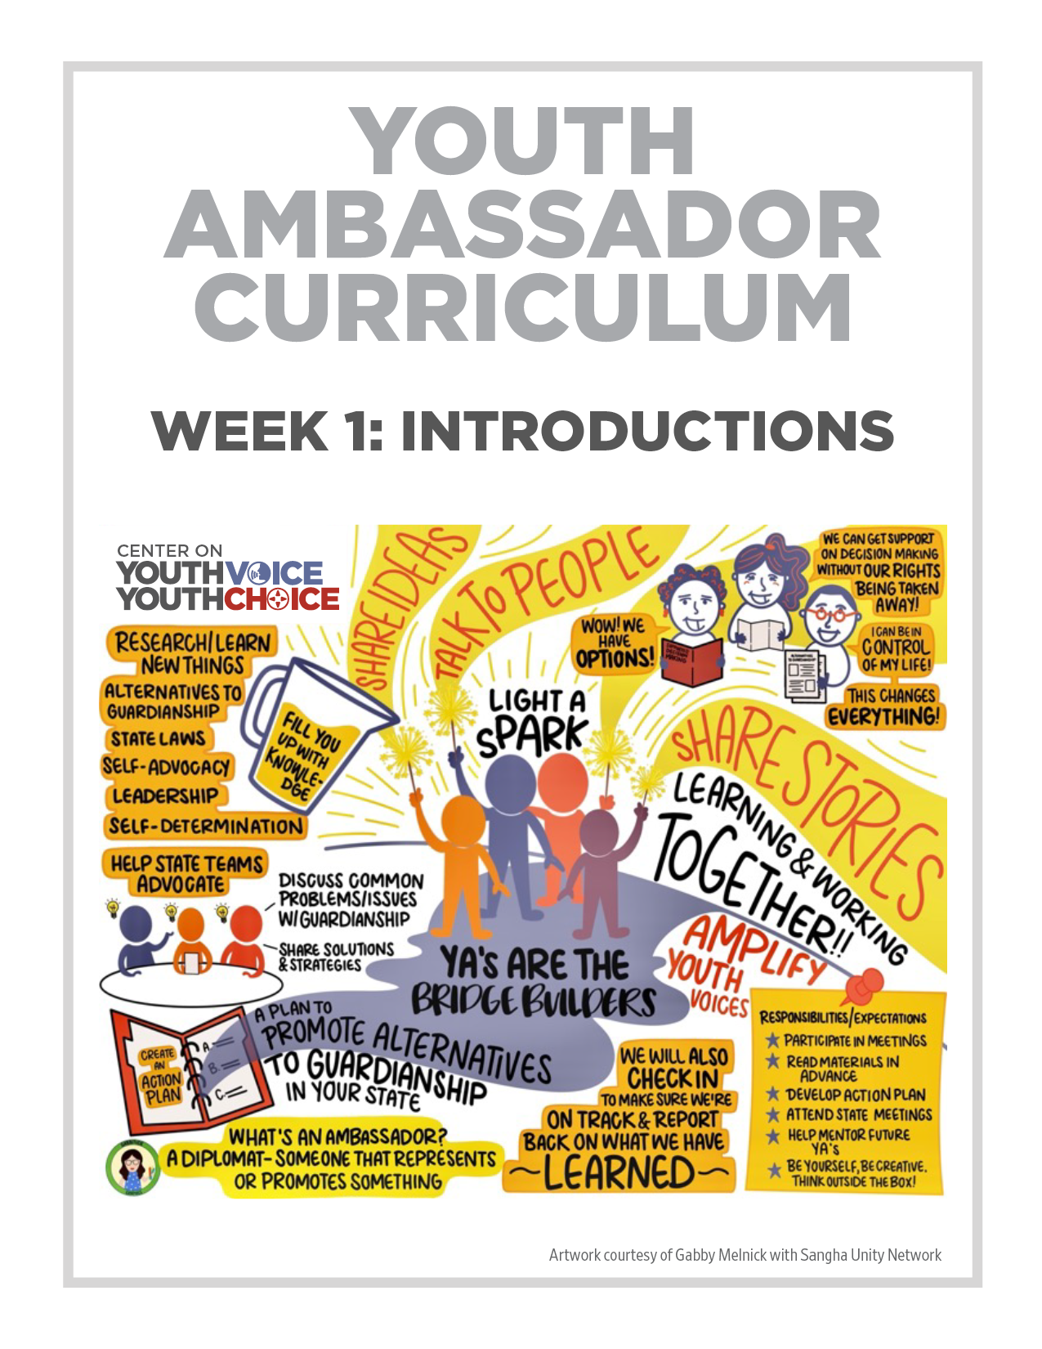
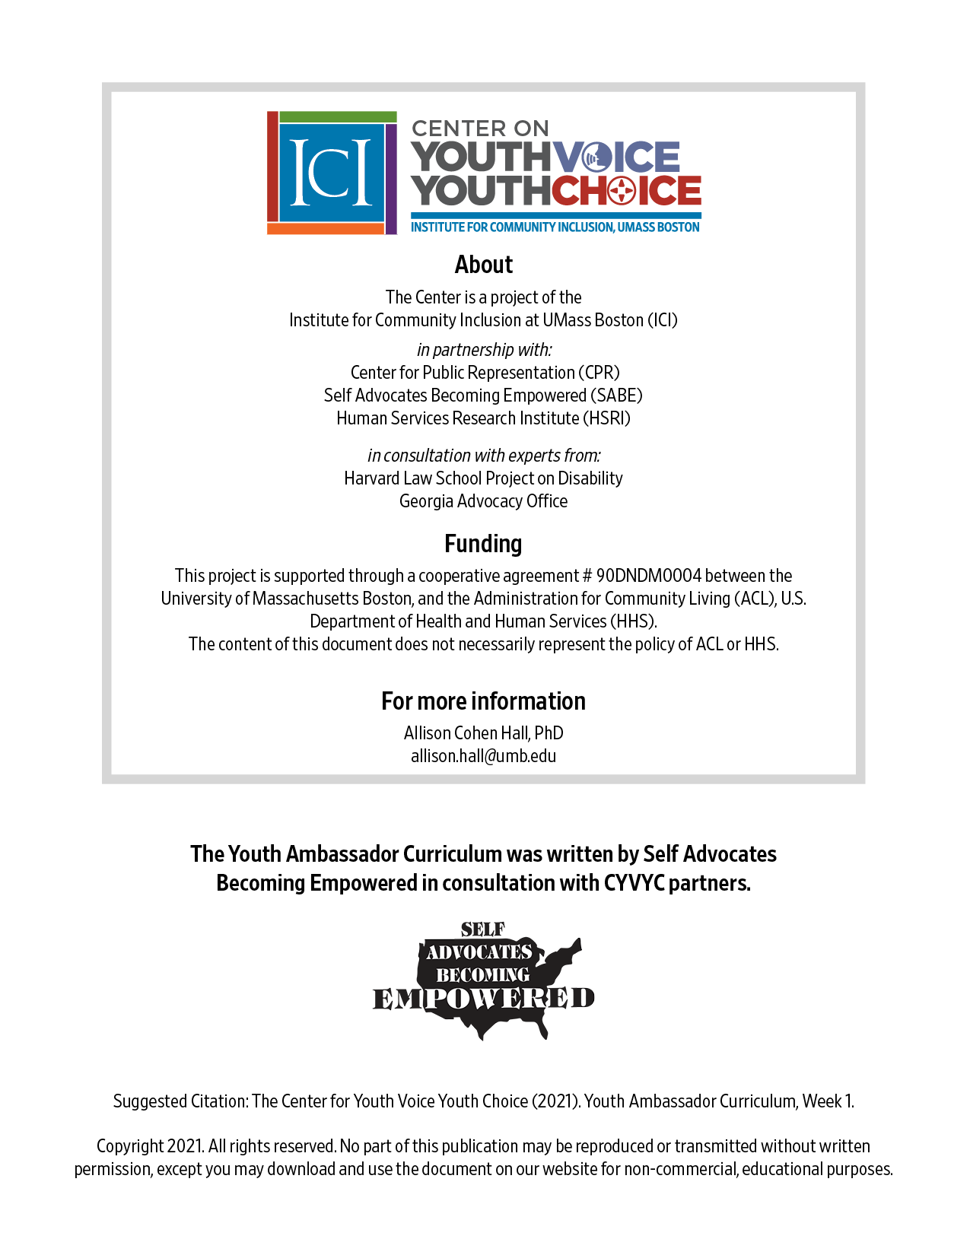
Welcome Facilitators

Week 1 - Introductions
Learning Objectives Facilitator

Words for the week: Facilitator

Youth ambassador – A young adult between ages 14 and 25 who shares information with people in his or her community about alternatives to guardianship
Guardianship - Guardianship is a legal process where a court names someone called a guardian to make decisions for someone else
Alternatives to guardianship - Alternatives to guardianship are TOOLS other than guardianship that people can use to get the support they need to make tough decisions about their lives
- Group discussion: Introduction Icebreaker 20 minutes Facilitator
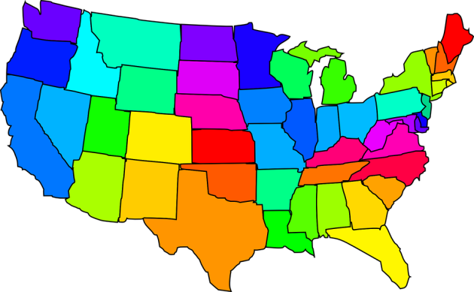
  - Where do you live?
  - Share 1 important decision you have made that you are proud of

- Presentation: Project overview 20 minutes Facilitator
  - What it means to learn together and learn from one another
  - The role of youth ambassadors in the project
    - What is an “ambassador” anyway?
    - Youth will receive a stipend for participating
    - Cultural translator, a communicator of ideas, bridge builder
  - So what is this project all about? MAKING DECISIONS!!

Welcome and hello
Introduce training team and ask each ambassador to state name and which state they are from.

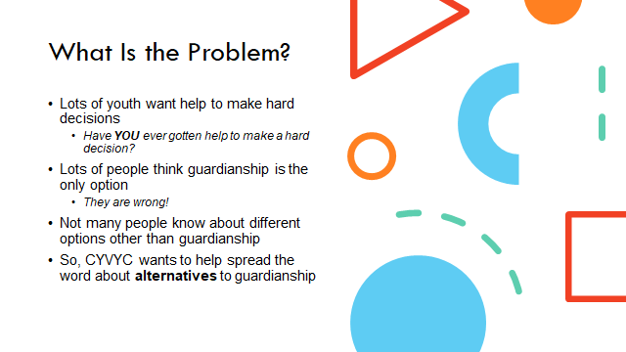
Youth = with intellectual and developmental disabilities

People = parents, teachers, doctors, or other professionals

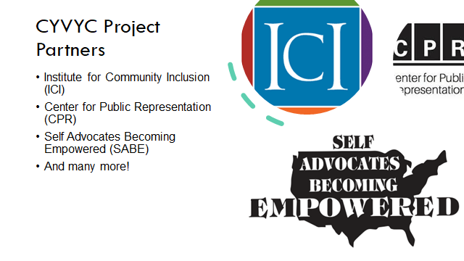

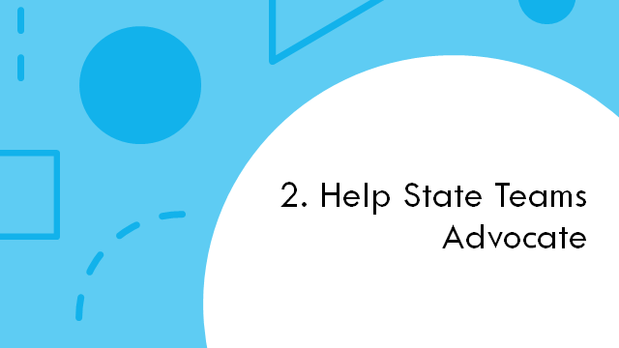

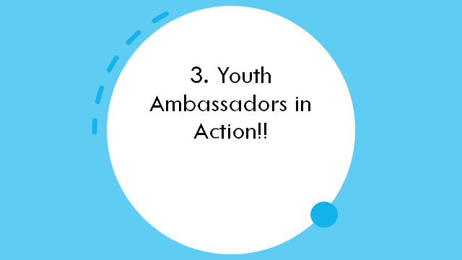

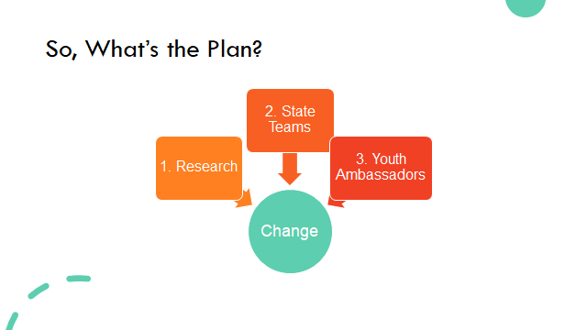

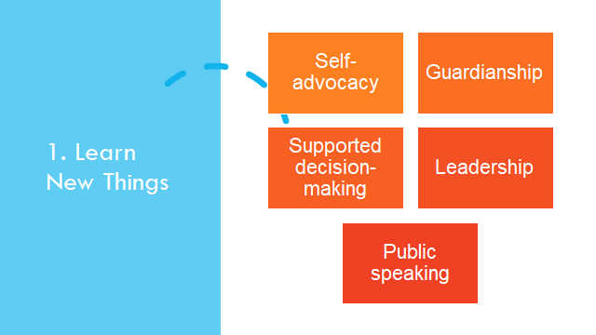

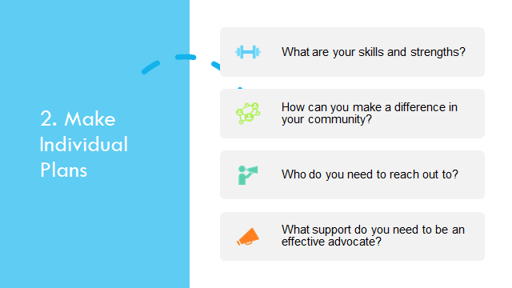

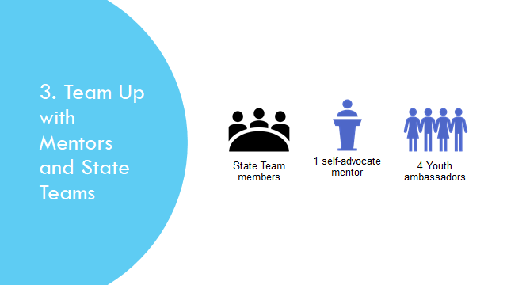

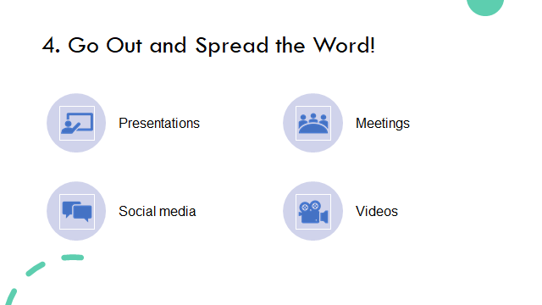

- Presentation:
Dress for success –10 minutes Facilitator
Share: Dress for success Handout
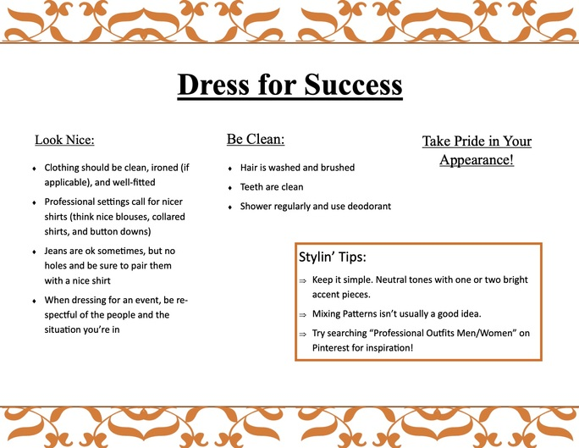

Zoom etiquette –10 minutes Facilitator

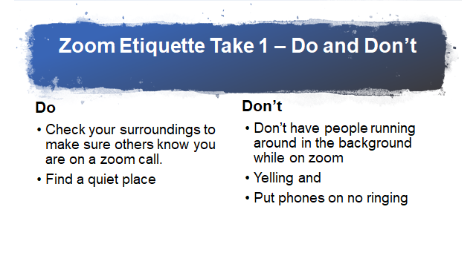
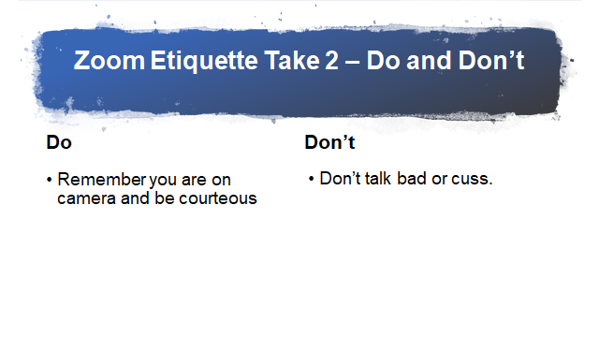

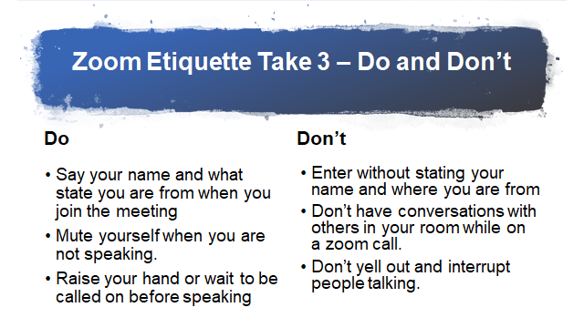

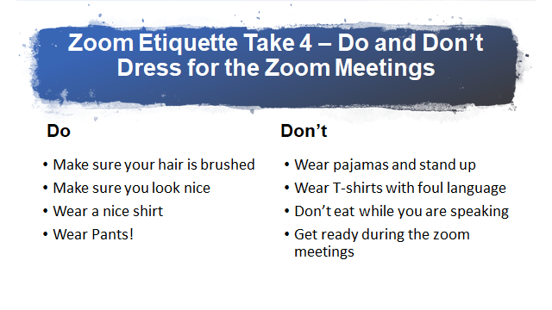

- Group discussion: 20 minutes Facilitator
  - What are your experiences so far in working with your state team?
  - If you have not met with your state team, do you need support?
  - What are the kinds of activities you will be doing and how will you be engaged in with your state?

5. What’s next? 10 minutes Facilitator

Now what next, but talk about what they would be doing the following weeks on homework

