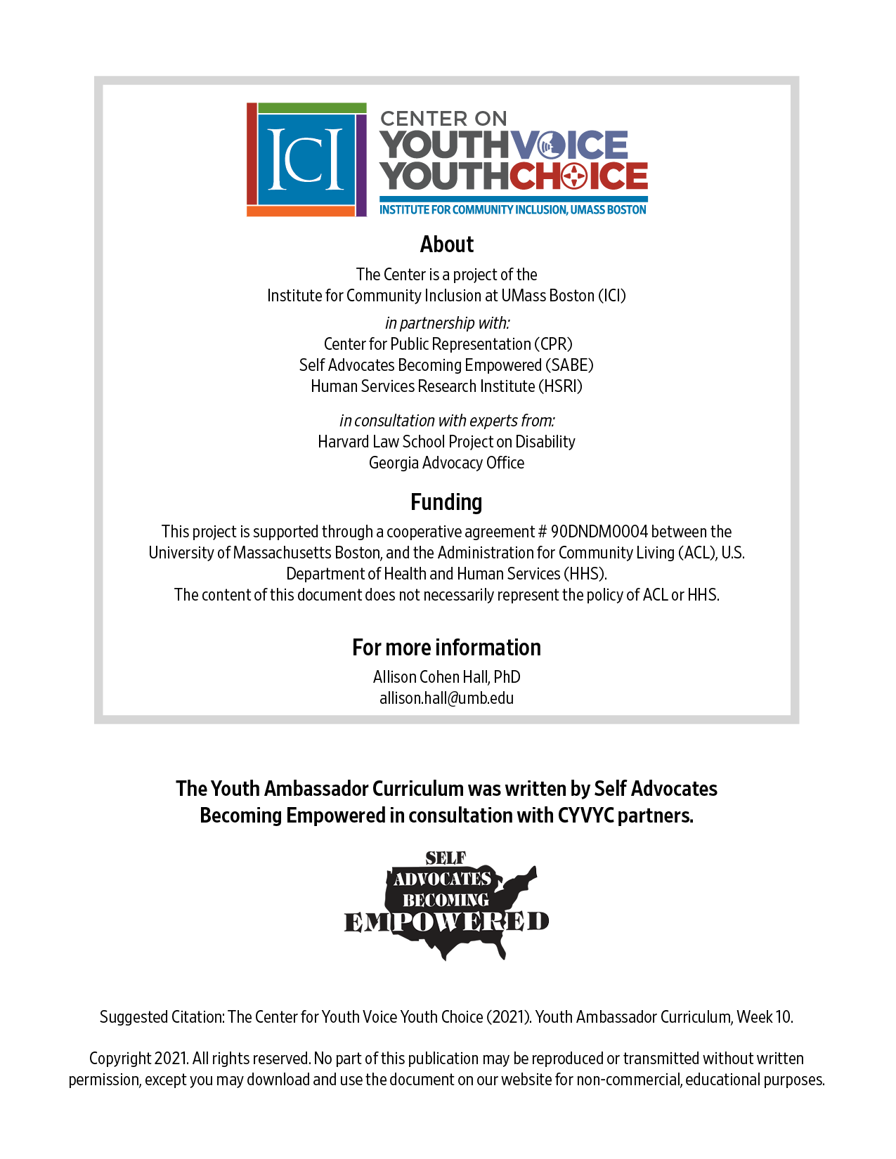

Week 10 – Pitch Perfect

Week 10 – Pitch Perfect
Learning Objectives Facilitator

Words for the week: Facilitator

Elevator speech – how you would talk to someone about an important topic to you, if you have a couple minutes

Audience
A group of listeners. Your audience will influence what you want to say and how you want to say it.

Body language
Pay attention to what you are saying. Watch people’s facial expressions.

Nonverbal cues (how someone looks or how someone sits) that can say a lot about what your audience thinks about what you’re saying. Be aware of your audience’s body language when you’re talking to them to advocate effectively.

Confidence
Belief in who you are or what you’re saying. If you believe in something or someone, you trust that person. That’s what confidence is all about.

- Group discussion: Introduction Icebreaker 30 minutes Facilitator
Share your vision boards.

- Small Group by state discussion: 20 minutes Facilitator
Talk about emails sent out them
In the Youth Ambassador class, we have been learning about supported decision-making, guardianship, advance directives, powers of attorney, and rep payees. I have some questions about how those are used in our state.

- Can someone in my state make a supported decision-making (SDM) agreement? How would that help them? If not, can you use SDM without an agreement?

- Can someone in my state use an advanced directive to appoint a health care agent? What kinds of decisions can that person make?

- Can someone in my state use a power of attorney to appoint a person to make health, money, and decisions about school on their behalf? How does that work?

- For people in my state who have representative payees, how can they make sure that their representative payees are doing their job right?

- For people in my state who have a guardian and don’t want a guardian anymore, how do they undo that?

- Have you done this…? 15 minutes Facilitator

Have you performed at a concert (band, orchestra, choir)?
Have you done a speech at school?
Did you run for student council?
Have you presented in front of 10 people? 25 people? More than 100 people?
- Elevator Presentation 15 minutes Facilitator

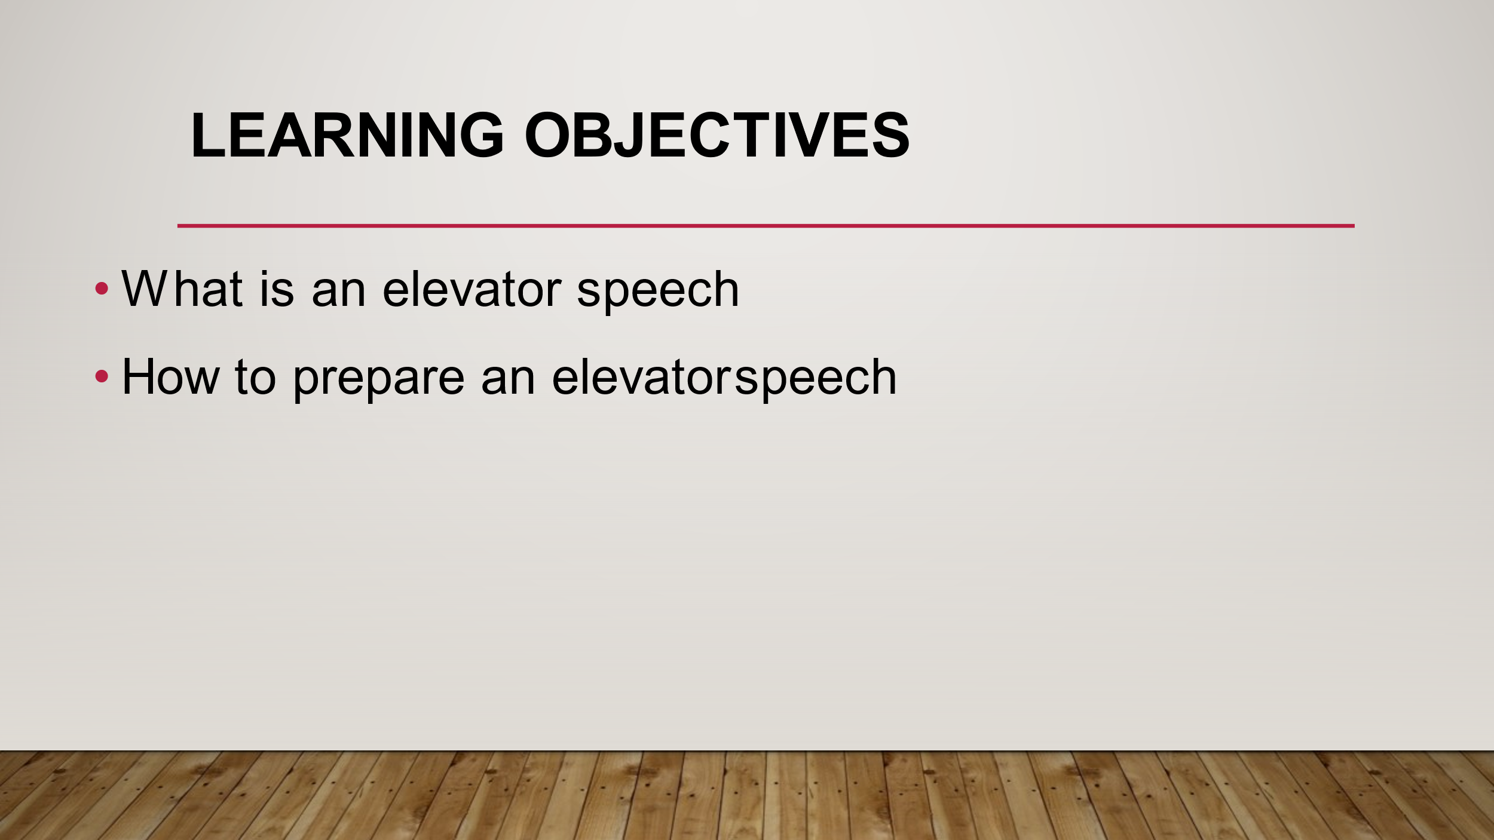
Elevator speeches should be your go to speech whenever you are telling someone about what you are doing in your state about Alternatives to Guardianship.

It is called the elevator speech because of how long it takes to say it, it should be short enough to be given in the same amount of time it would if you were to take a ride in an elevator. It should inform someone about Alternatives to Guardianship.

Always keep in mind who is your target audience when creating an elevator speech. Your speech should not be set in stone. You should be able to change it depending on who you are talking with.

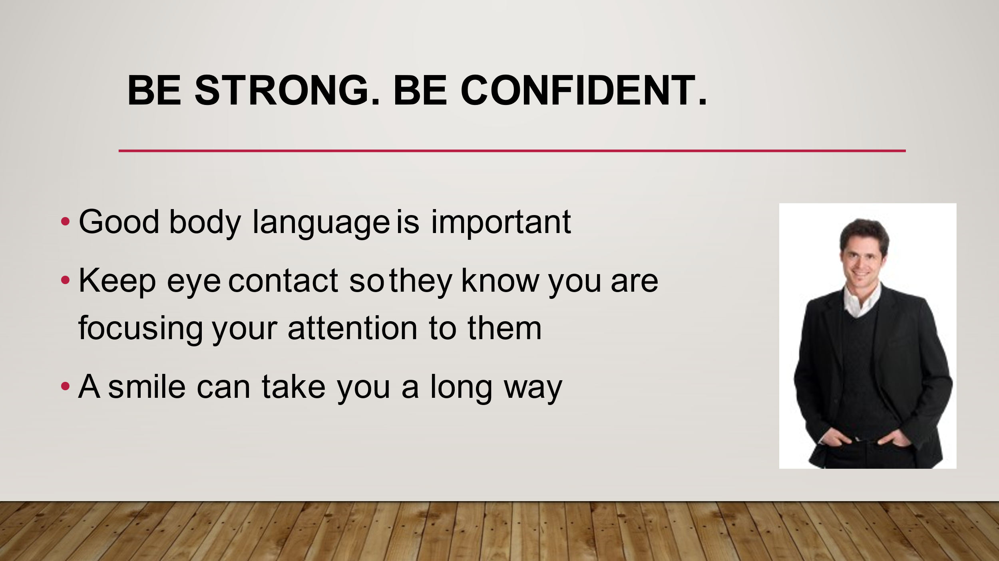
Confidence and body language are very important when speaking to someone. By showing confidence, you are telling the listener that this is important and you know what you are talking about.

You should also maintain eye contact. Keeping eye contact lets the listener know that they are the focus of your attention and are more likely to listen to what you have to say.

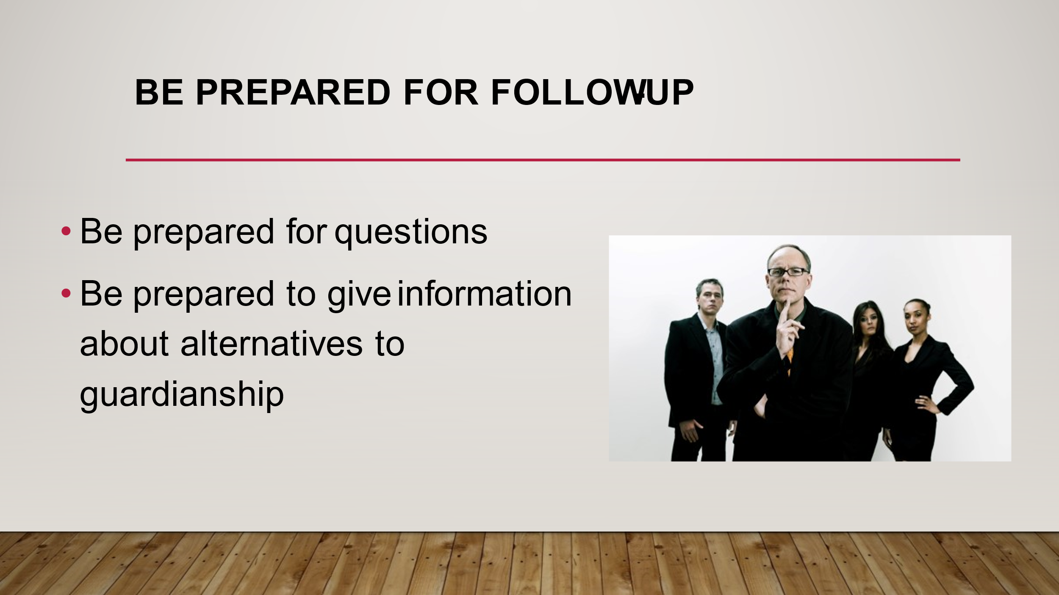
After you give your speech, the listener may have questions about your speech. Be prepared to answer questions the listener may have. It is a great way to share additional information if you did not have time during your speech. If possible, have information available to give to the listener to take home. This can be a flyer, brochure, or a business card.

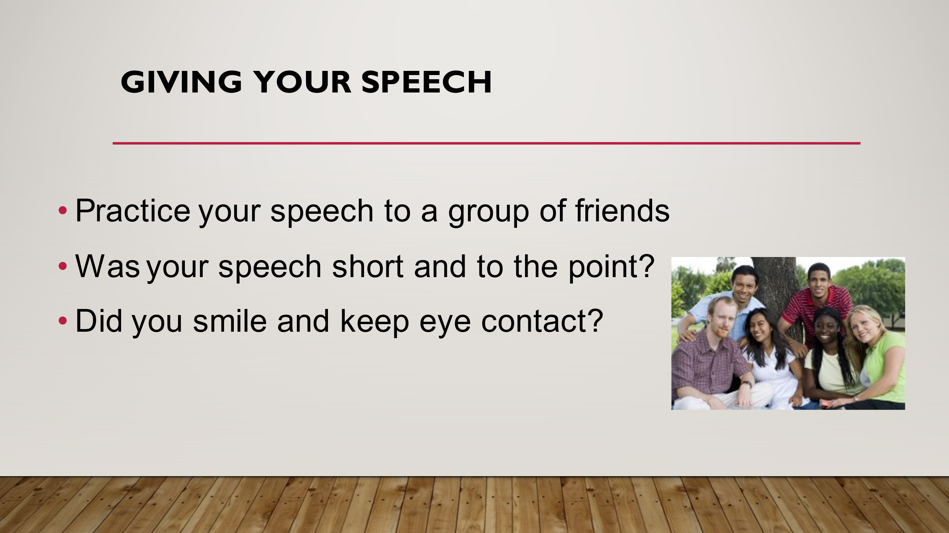

- Large group session: Alternatives to guardianship Elevator Speech 10 minutes Facilitator

What are some things you can tell someone about Alternatives to Guardianship?

- What’s next? Facilitator
Learn what is happening in your state

Step 1 call someone from your state COP to interview them. You have been emailed instructions to interview someone from your state. Questions will be sent to you this Friday and Allison went over them earlier.

Step 2 introduce yourself and thank them for their time.

Step 3 ask 5 questions about Guardianship, Supported Decision-Making, Rep Payee, Power of Attorney rules and laws in your state.

Step 4 report back to the group.

