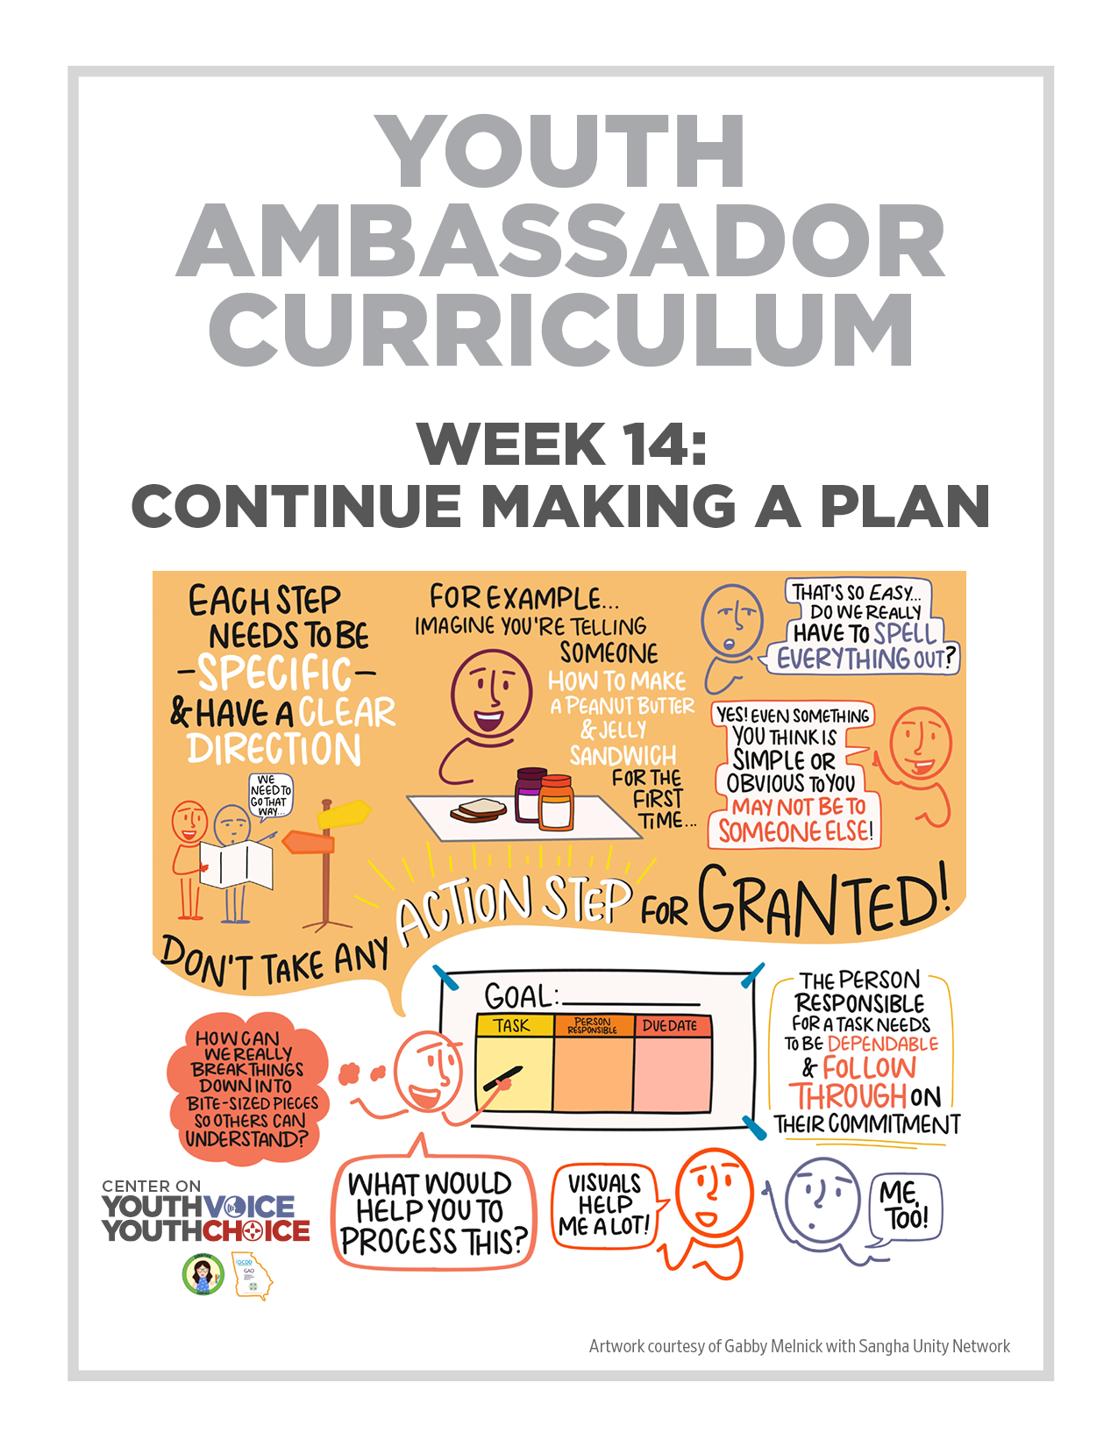
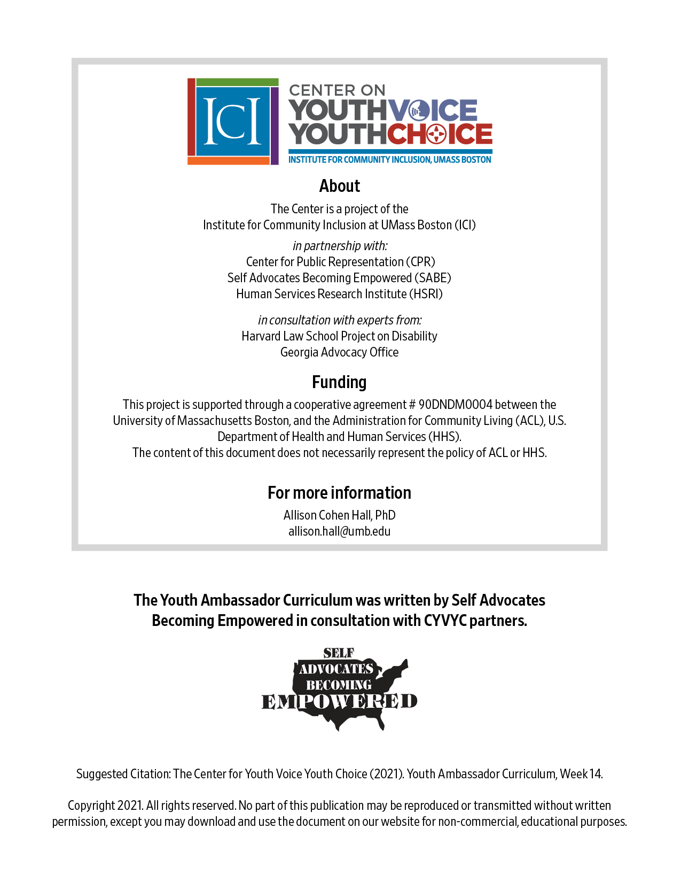
Week 14 – Continue Making a Plan
Learning Objectives Facilitator

Words for the week: Facilitator

Action plan – is a detailed outline of your actions to complete a goal or a sequence of steps that must be taken to succeed

Task – a job or something that needs to be done

Responsible person – being dependable, making promises and keeping promises and honoring your commitment, being the person who makes sure the work is getting done

Due date – the time when something has to be done

- Small group activity (break up by state with a facilitator): Give and get feedback on S.M.A.R.T. goals and objectives 20 minutes Facilitator
Room by state | Facilitator | Notetaker
State 1 | Person 1 | Person 4
State 2 | Person 2 | Person 5
State 3 | Person 3 | Person 6

- Large group discussion: Making an action plan 25 minutes Facilitator
  - Say that action plans are like recipes, and we’ll start out working on a simple one. Ask a volunteer to describe the recipe for a peanut butter and jelly sandwich. Write down the steps that participants call out on the Zoom whiteboard. Point out if they miss any steps that would lead to the sandwich coming out wrong. Ask the participants to fill in gaps if they leave anything out.
  - Next, review the Sample Action Plan template all together.
  - Ask youth ambassadors if the first goal is S.M.A.R.T. or not, and ask them to explain why.
  - Describe how each task or step says who will do it and when it will be done by.
  - Ask them to notice how each step builds on one another. Ask them for ideas about any gaps in the steps.
  - Next, do the same for goals 2 and 3, but cover up or delete some of the boxes for tasks, responsible persons, and due dates. Ask the youth ambassadors to try to fill in the blanks.

- Large group discussions: Making individualized action plans 20 minutes Facilitator
  - Using the Blank Action Plan template, the facilitator should ask for one volunteer to describe some steps that would be needed to take to accomplish one of the goals identified earlier. Ask other volunteers to offer their suggestions.
  - Ask for another volunteer and repeat, until everyone in the small group has an opportunity to brainstorm some steps with others.
  - Save each whiteboard for each volunteer as an image file and share them with the participants so they can reference at home.
Goal 1:
Task List | Who will do the task? | Timeline

My CYVYC Project Action Plan
Overall Goal:
I want to make youth with intellectual or developmental disabilities in my state more aware of alternatives to guardianship.

Objective 1:
I will record a YouTube video on how I filled out a power of attorney and get 200 views in 3 months.

Steps | Who will do it? | When will it be done?
- Write a script about my experience | Me | Nov 1, 2021
- Get feedback from my supporters on my script | Me, my supporters | Dec 1, 2021
- Make changes to my script based on their feedback | Me | Jan 1, 2022
- Watch a tutorial or take a training on how to make good videos | Me | Mar 1, 2022
- Record myself with the help of a friend | Me, my friend | Mar 15, 2022
- Edit the video or ask a friend for help with editing | Me, my friend | Mar 31, 2022
- Upload the video to YouTube | Me | Apr 15, 2022
- Share the links to my video on my other social media accounts | Me | Apr 15, 2022
- Ask organizations and people I know to like and share the video | Me, my friends, my state team members | Apr 30, 2022

Objective 2:
I will make an easy read factsheet for students with intellectual or developmental disabilities in my school district about what questions they can ask their IEP teams about the transfer of rights starting in the fall of 2022.

Steps | Who will do it? | When will it be done?
- Search for information for students with intellectual or developmental disabilities from other places | Me | Oct 31, 2021
- Ask self-advocates I know what their biggest questions were when they learned about transfer of rights | Me | Nov 30, 2021
- Research answers to their questions | Me | Dec 31, 2021
- Ask members of my state team to check my research and help me fill in the gaps | Me, state team members | Jan 31, 2022
- Fit my answers into a one-page flier or decide if I need more space | Me | Feb 28, 2022
- Search for photos or images to make my factsheet pop | Me | Mar 31, 2022
- Show it to students and teachers I know and my state team members to get their feedback | Me, state team members, teachers, students | Apr 30, 2022
- Make changes that my state team members and students suggested | Me | May 31, 2022
- Print out copies of the final version and share them with teachers I know | Me | June 30, 2022

Objective 3:
I will hold 3 trainings for 20 students with intellectual or developmental disabilities in my school district about supported decision-making in the next 10 months.

Steps | Who will do it? | When will it be done?
- Write a lesson plan for the training sessions | Me | Sept 1, 2021
- Get feedback on my lesson plan from my supporters | Me, my supporters | Sept 15, 2021
- Ask my teachers for a meeting to present my training idea and lesson plan | Me | Oct 1, 2021
- Present my plan and ask for permission to hold 3 trainings at my school | My teachers | Oct 15, 2021
- Choose 3 dates for the training sessions | Me, my teachers | Oct 31, 2021
- Make a flyer and share it with students | Me, my teachers | Nov 15, 2021
- Make a PowerPoint presentation for the first training | Me | Dec 1, 2021
- Practice my presentation for the first training | Me, my supporters | Dec 15, 2021
- Print out handouts for the training, including a participant survey | Me | Jan 1, 2022
- Visit the training room to try out my slides | Me, my supporters, my teachers | Jan 8, 2022
- Hold the first training session | Me, my supporters, my teachers, students | Jan 30, 2022
- Review participant surveys and discuss with my supporters | Me, my supporters | Feb 15, 2022
- Make changes to my PowerPoint presentation and my lesson plan | Me | Feb 28, 2022
- Hold the second training session | Me, my supporters, my teachers, students | Mar 15, 2022
- Review participant surveys and discuss with my supporters | Me, my supporters | Mar 31, 2022
- Make changes to my PowerPoint presentation and my lesson plan | Me | Apr 15, 2022
- Hold the third training session | Me, my supporters, my teachers, students | Apr 30, 2022
- Review participant surveys and discuss with my supporters | Me, my supporters | May 15, 2022
- Meet with my state team members to discuss my experience | Me, my supporters, state team members | May 31, 2022

Blank Planning Template
Overall Goal:

Goal 1:
Task List | Who will do the task? | Timeline

Goal 2:
Task List | Who will do the task? | Timeline

Goal 3:
Task List | Who will do the task? | Timeline

- What’s next? 10 minutes Facilitator
Continue to work on individual action plans using the Blank Action Plan template and the notes from the small group discussions.

Complete an action plan with the chart completely filled out for 3 goals.

