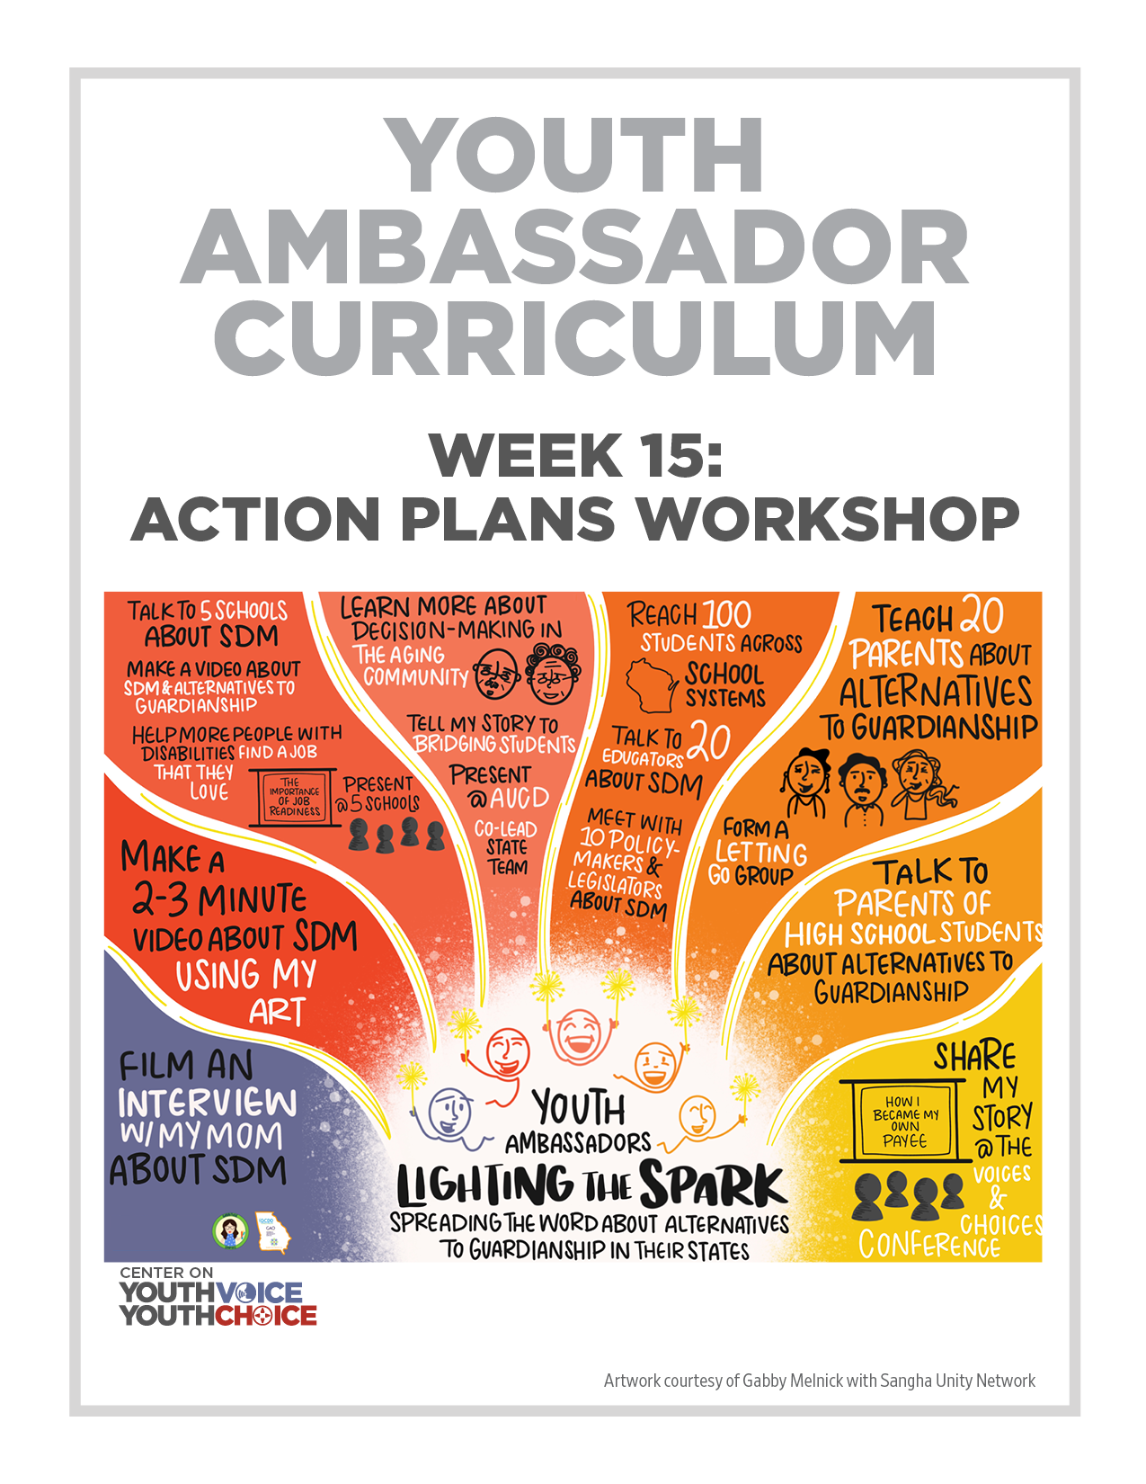
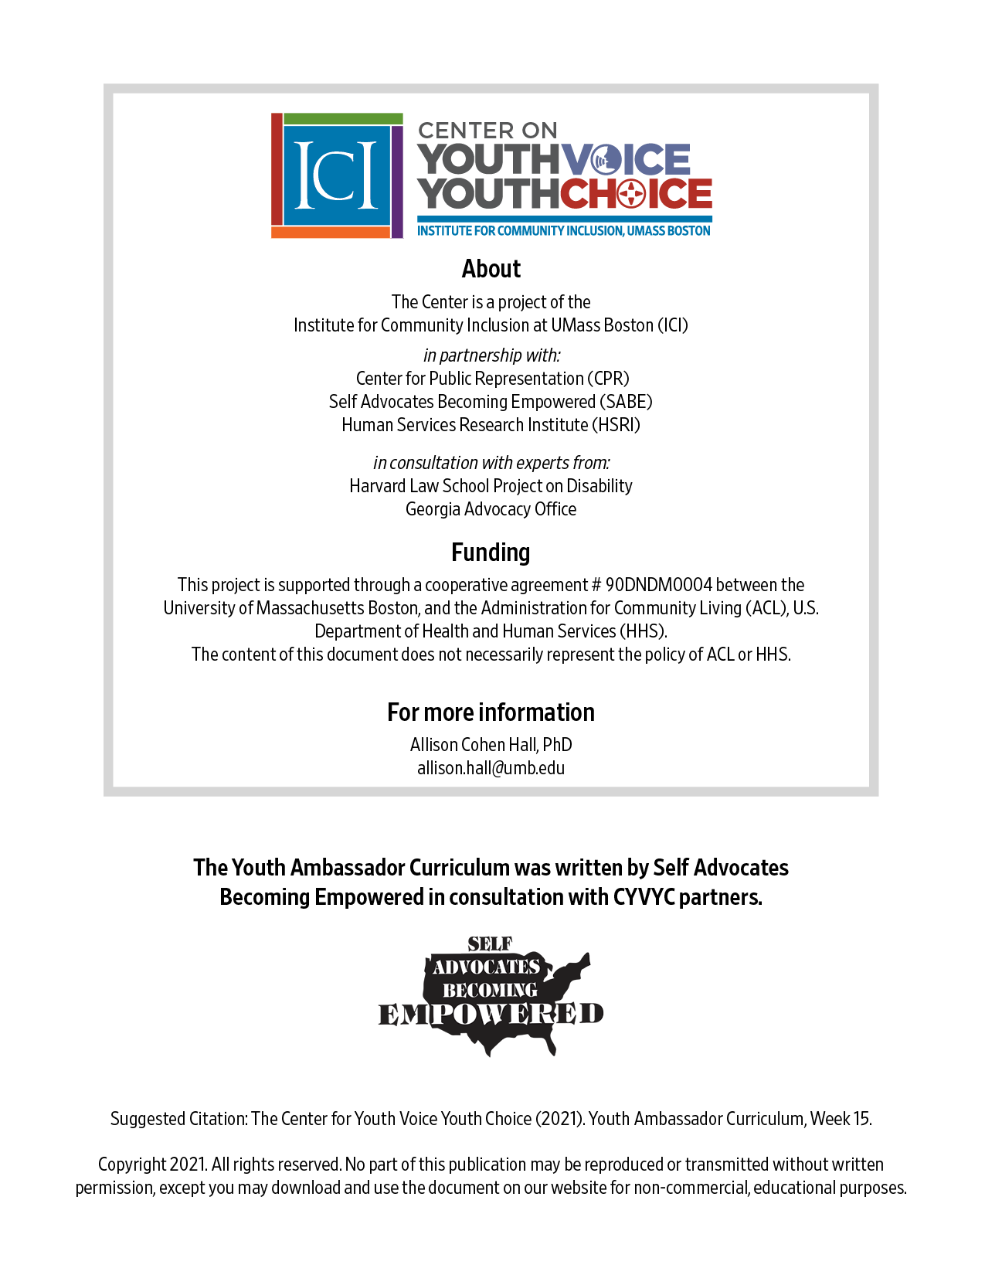
Week 15 - Presentation
Learning Objectives Facilitator

- Tell us about your interview, if you have not 10 minutes Facilitator

- Large Group: Share 1 SMART Goal 20 minutes Facilitator

- Large Group: Share your SMART Objectives 20 minutes Facilitator
  - Ambassador 1 will share his plan with the group
  - Ambassador 2 will share her plan with the group

- Small group: Action plan workshop 30 minutes Facilitator
  - Look at the template
  - Talk over their plan
  - Ask these questions:
Do you have at least 3 Goals?
Are they SMART?
Is there an action plan?
Is the action plan complete and SMART?
What format will you use to give the information or message?

Room by state | Facilitator | Notetaker
Room 1 main State 1 | Person 1 | Person 4
Room 2 State 2 | Person 2 | Person 5
Room 3 State 3 | Person 3 | Person 6

Goal 1:
Task List | Who will do the task? | Timeline

- What’s next? 10 minutes Facilitator
Prepare one part of your plan to present to the group.

Instructions
Step 1 Send Facilitator your plan: outline, video, picture. You decide!

Step 2 Come to office hours or ask your state team, if you need help

Step 3 Due by Wednesday, October 6

