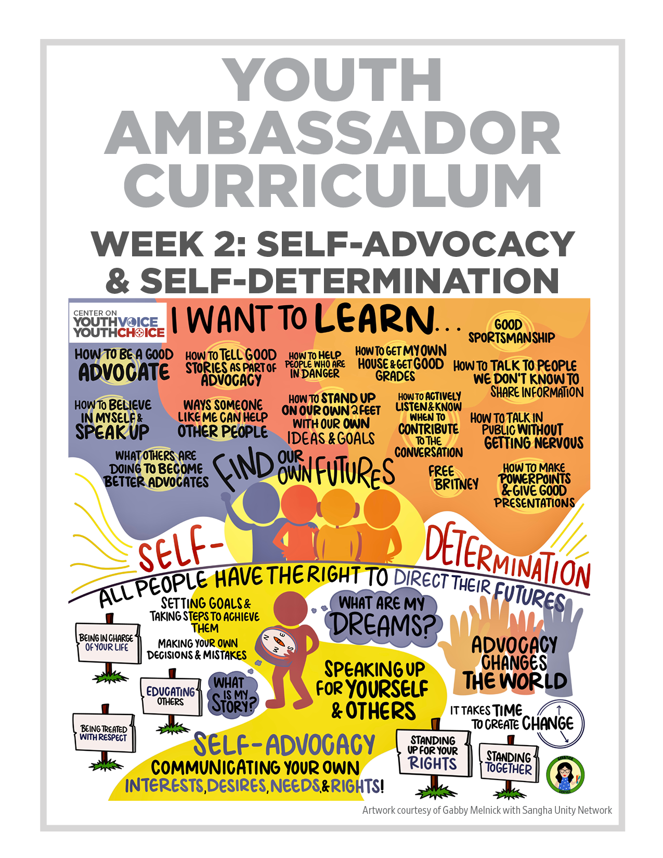
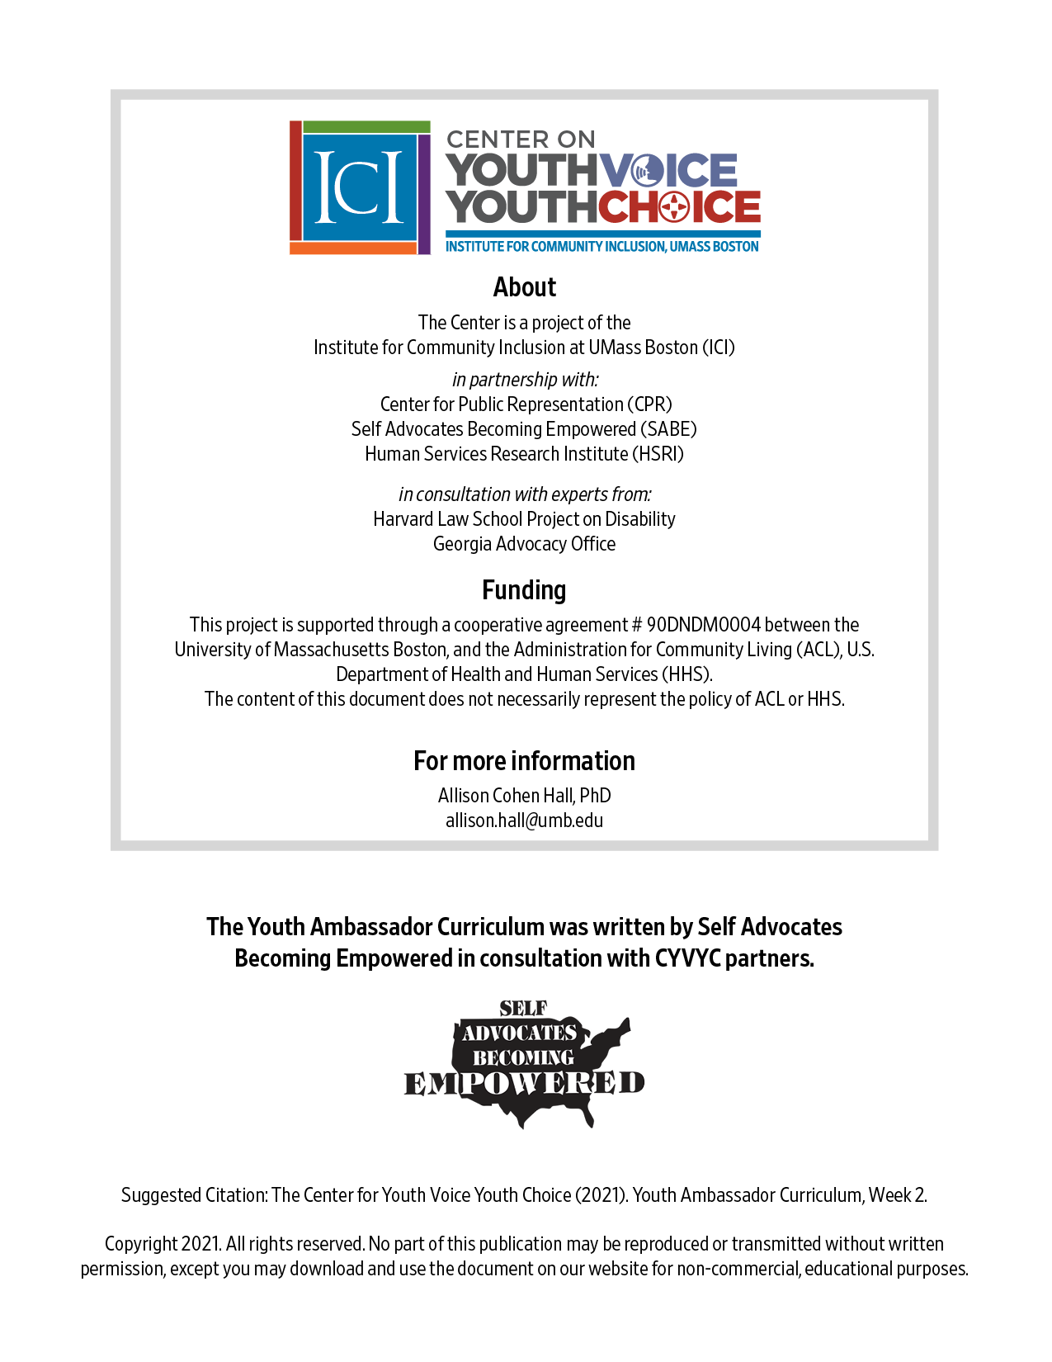
Week 2 – Self Advocacy
Learning Objectives Facilitator

Words for the week: Facilitator

Self advocacy – making change for your disability community

Self Advocate is someone who speaks up for themselves and others about their wants and needs

Self-determination –making decisions about your life and taking steps to get there, you can ask for help if you need it

Independence – freedom, ability to make choices and not have others tell you what to do unless you ask them to

Respect – other people are important, treat others how you want to be treated

- Group discussion: Introduction Icebreaker 20 minutes Facilitator

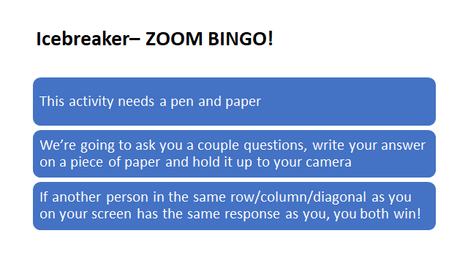

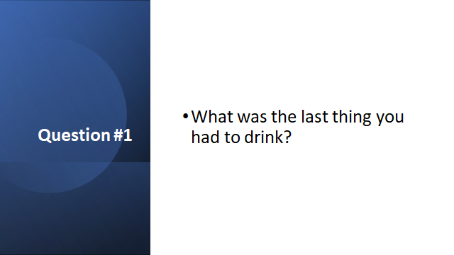

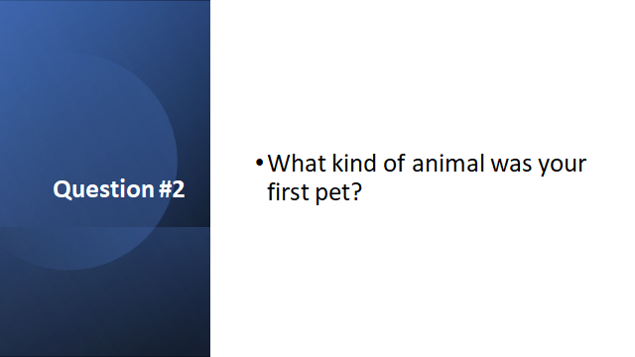

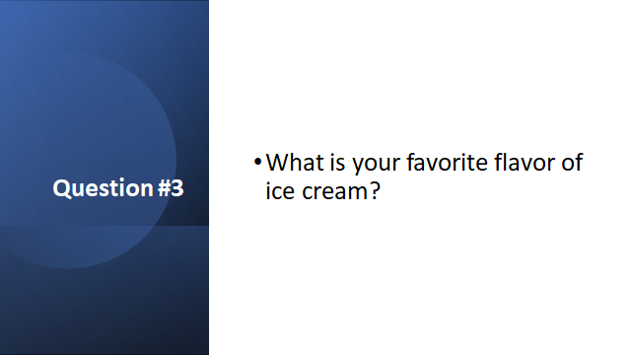

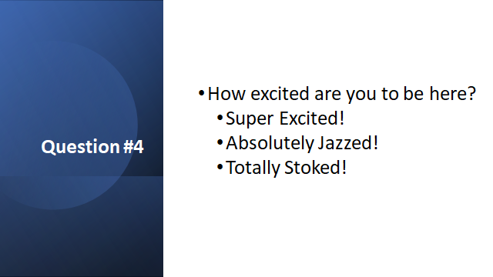

- Group discussion: What do you hope to learn about this training? Put in chat and let people know if they want to share live or put in the chat. Facilitator

- Presentation: What is self advocacy all about? Facilitator

  - Big stuff: closing institutions, advocating for the ADA, etc.
  - Little stuff: examples from people’s personal lives

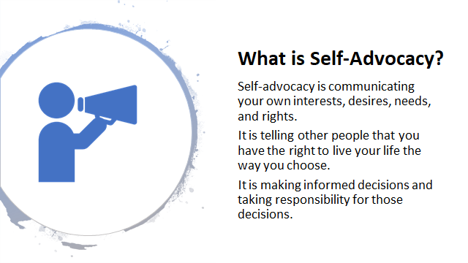

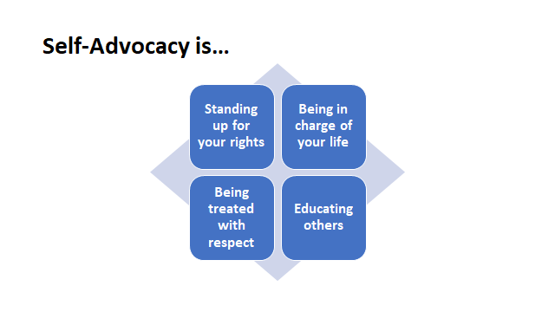

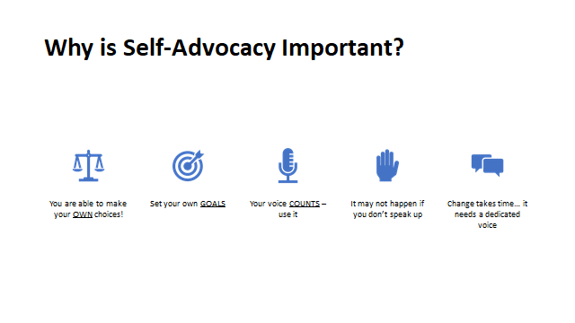
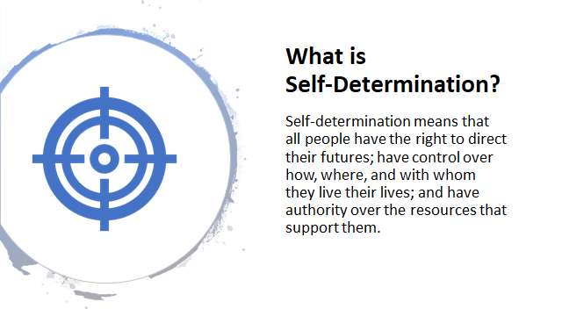

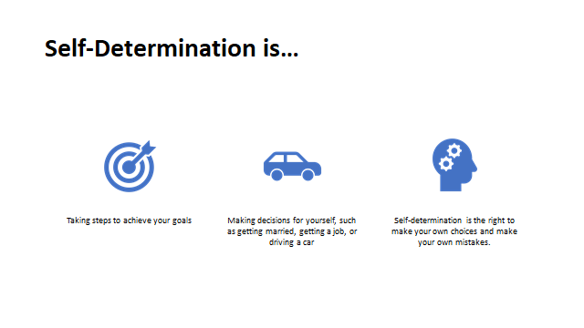
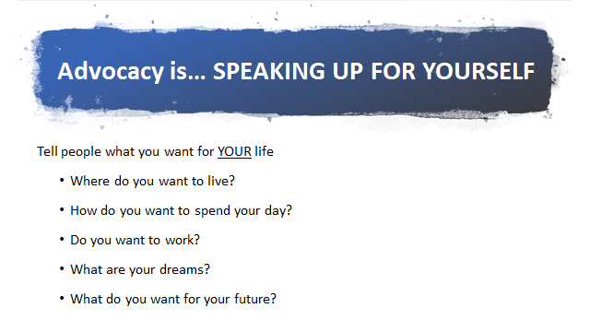

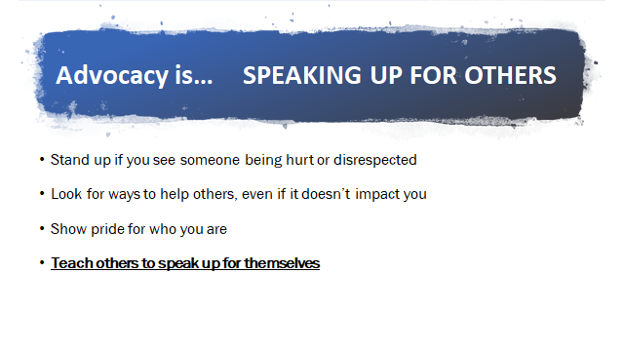

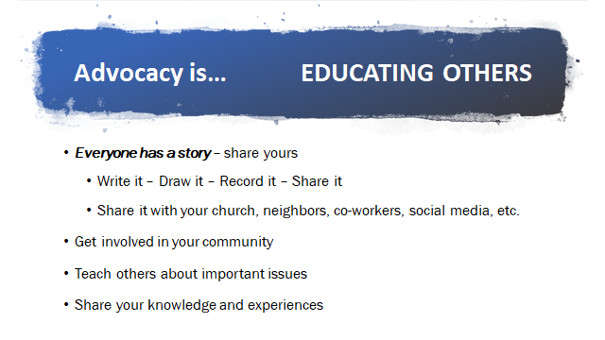

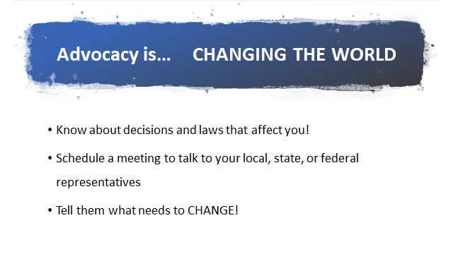

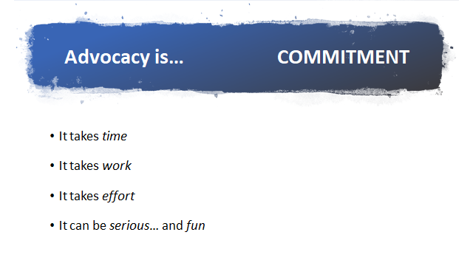

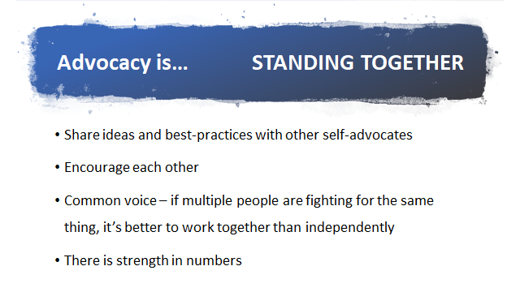

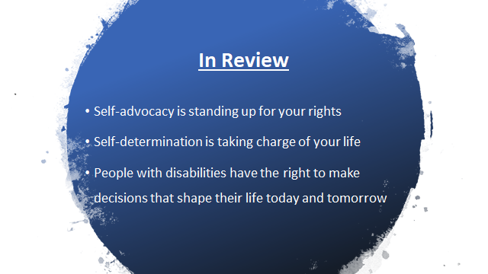

- Small group discussions and large group reports: Facilitator
  - What are examples from your life of self advocacy?
  - When has self advocacy been difficult? How did you handle that?

5. What’s next? 10 minutes Facilitator

Watch a self-advocacy video from SARTAC library

https://www.selfadvocacyinfo.org/self-advocacy/

