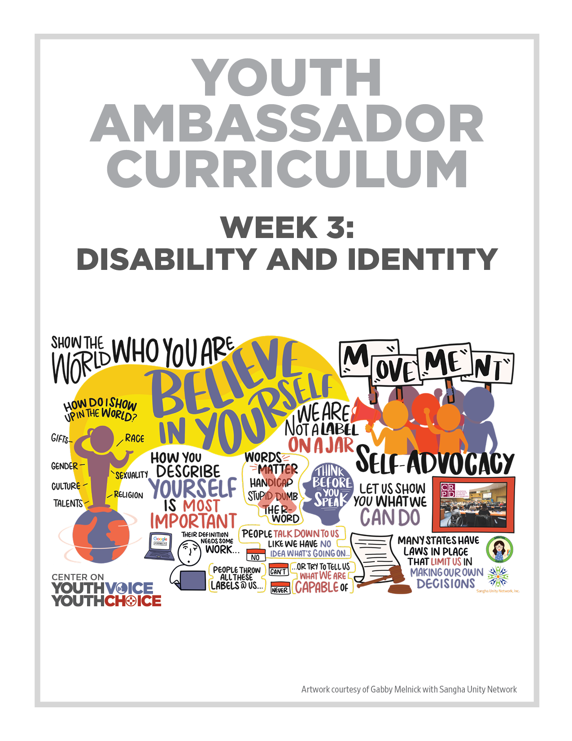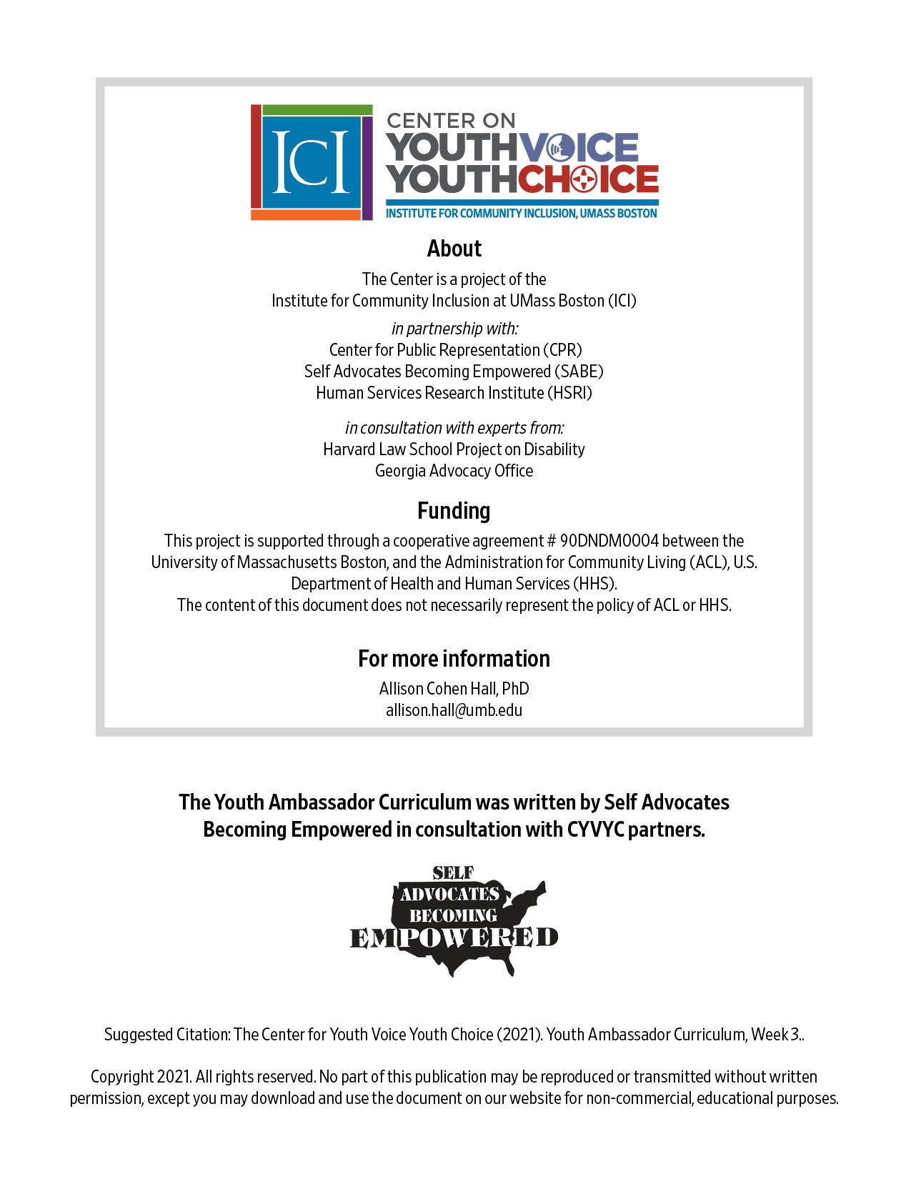
Week 3 – Disability and Identity
Learning Objectives Facilitator

Words for the week: Facilitator

Ability - skills to do something. Talent or skill you have in an area that you learned over time.

Believe in yourself - having faith that you CAN do something. When you believe in yourself, you can overcome self-doubt and have the confidence to take action and get things done.

- Group discussion: Introduction Icebreaker Facilitator 20 minutes
Having people talk about what they do in their spare time helps to get an idea on who they are (identity)

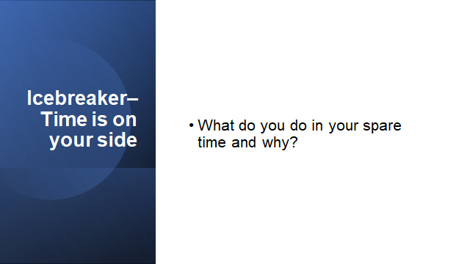

- Group discussion: Facilitator 20 minutes
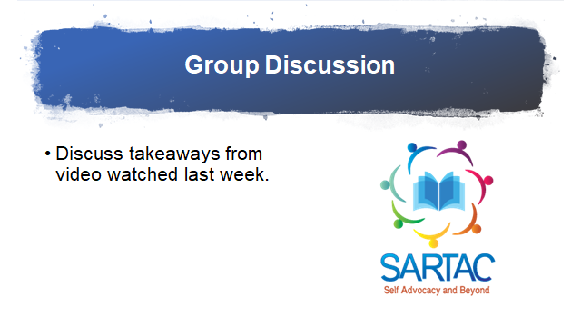

- Presentation: Facilitator 20 minutes

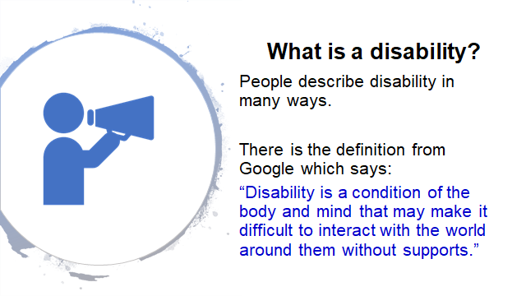

Google does not reflect what an individual says or knows about disabilities. Don’t believe everything on Google.

How does it make you feel, Darren? It makes me mad. You need help with this or have something explained. They should ask me when I need help. It is other people’s attitudes towards’ disabilities.

Darren – you did not agree with the definition of google during the discussion. Expand on the definition and whether you agree with it or not. Encourage those who don’t agree with the definition to call google.

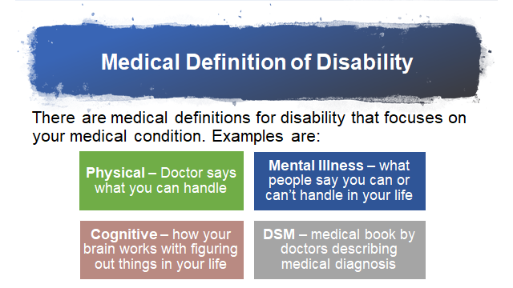

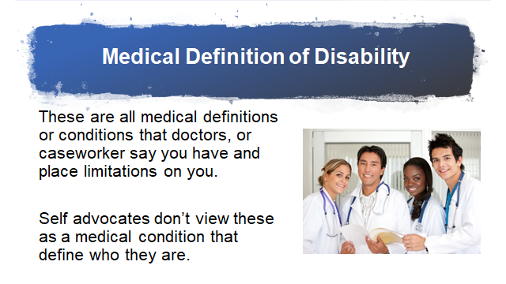
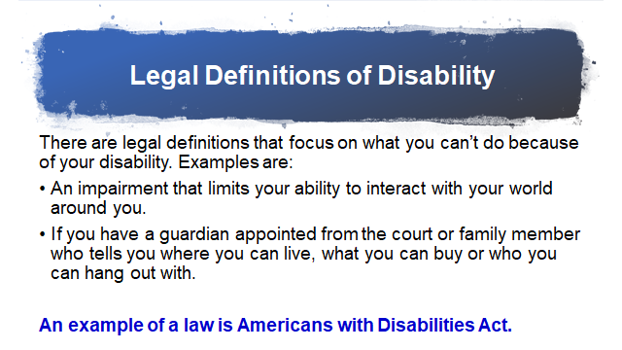

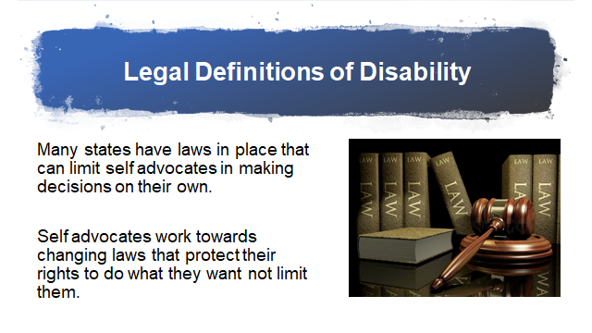

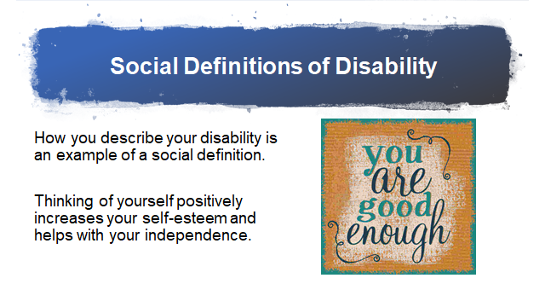

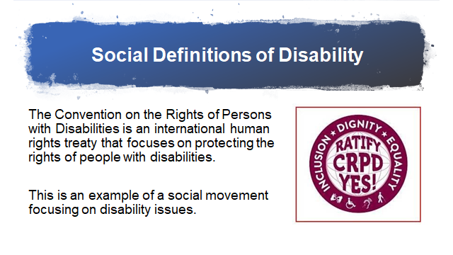

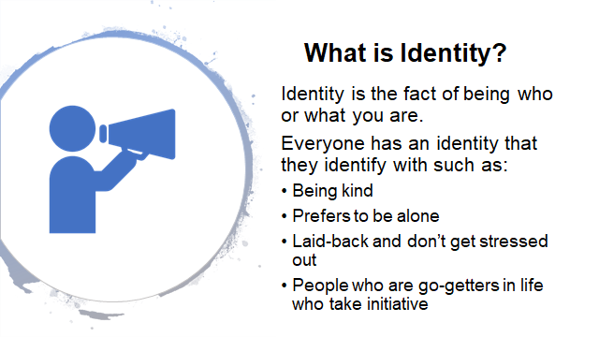
These identities focus on the person’s place in society – rich, poor, middle class and job;
Need to focus on the person.

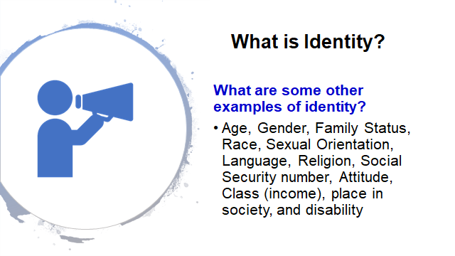

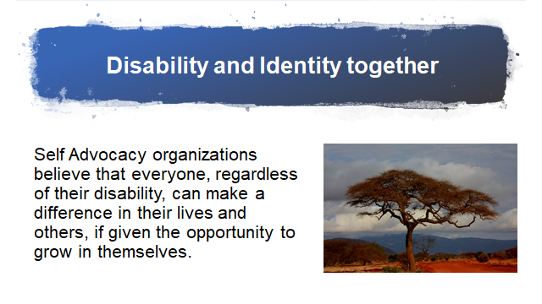

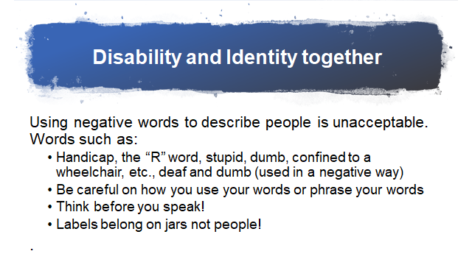
- Small group discussion and large group reports: Facilitator 40 minutes
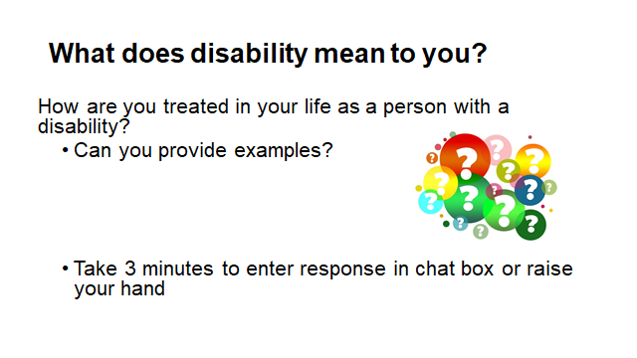

 | Lead | Note taker | Watch chat box
State A | Person 1 | Person 4 | Person 7
State B | Person 2 | Person 5 | Person 8
State C | Person 3 | Person 6 | Person 9

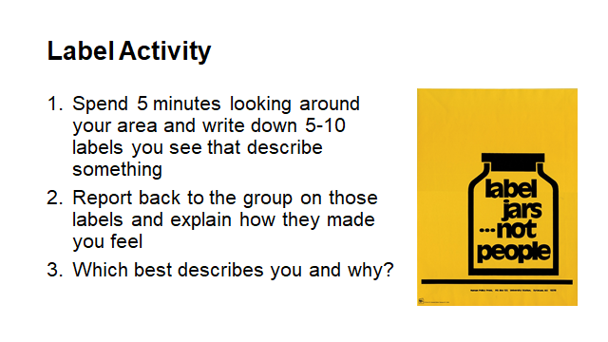

SARTAC White paper on self advocacy link:
https://www.selfadvocacyinfo.org/resource/our-common-history-fighting-for-the-rights-of-people/

- What’s next? 10 minutes

Reflect on today’s discussion – What does disability mean to you?

Is there anything we can do better to help you understand?

What are we doing right? What is really helpful for you?

Did you like the icebreakers? The PowerPoints? The group discussion?

Read the SARTAC white paper on self advocacy

Instructions needed
Step 1 How are you treated as a person with a disability?

Step 2 What do you want to change about how people treat you?

Step 3 What do you want people to know about disabilities?

