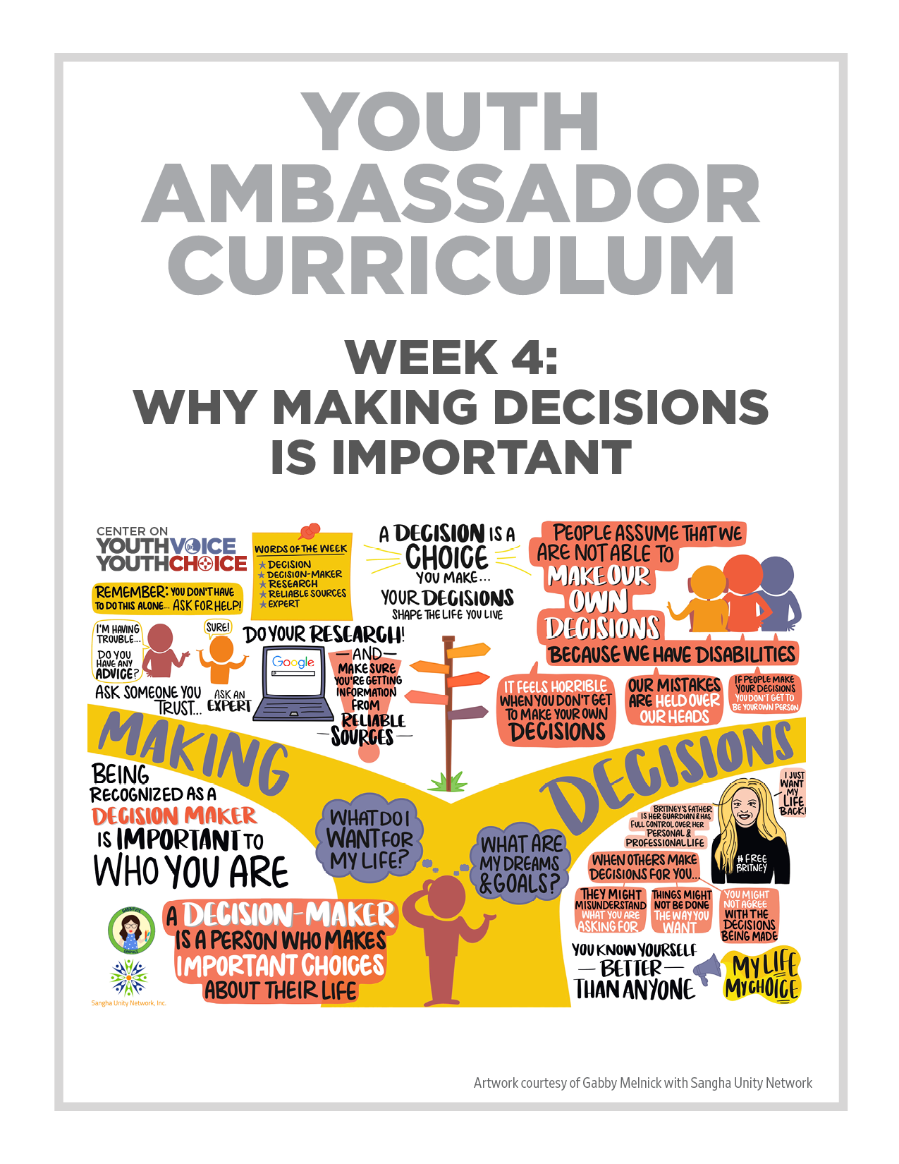
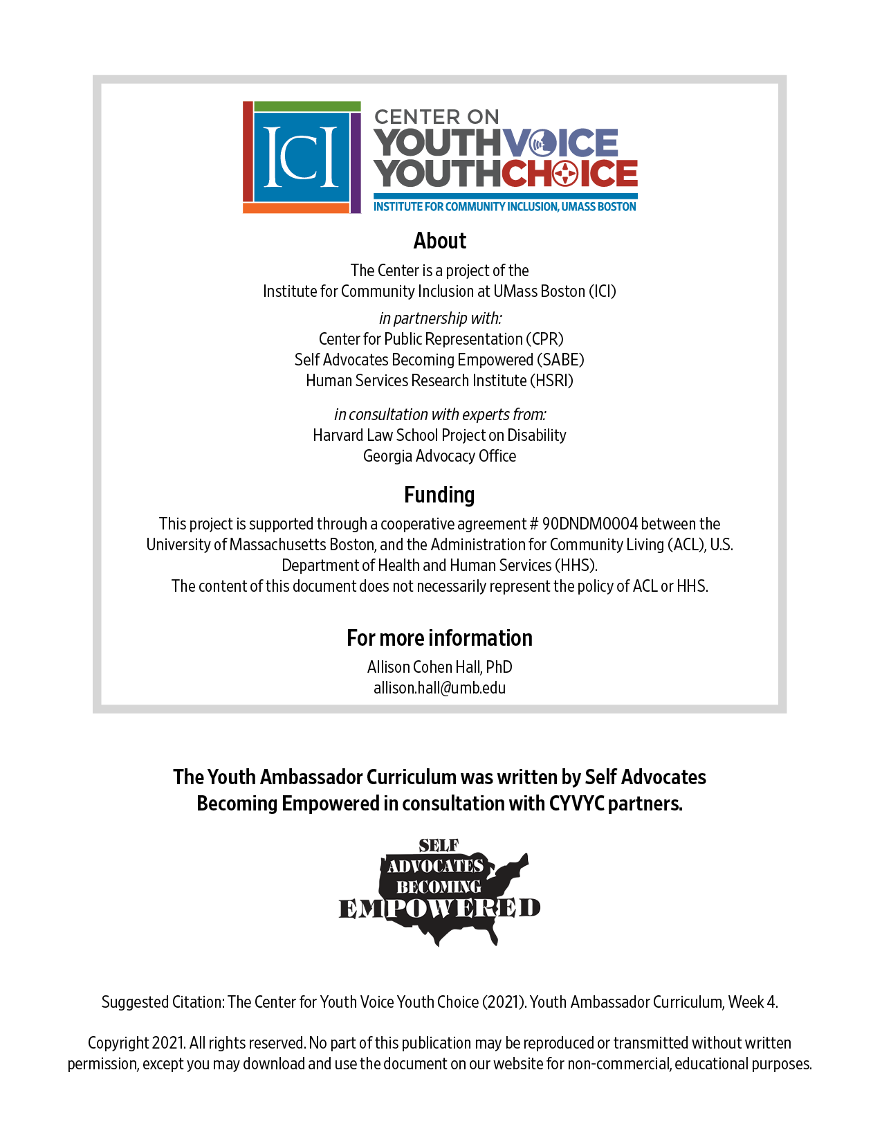

Week 4 –

Why Making Decisions is Important

Week 4 – Why Making Decisions is Important
Learning Objectives Facilitator

Words for the week: Facilitator

Decision – choice

Decision-Maker - a person who makes important choices about his or her life.

Research – a study on information to learn something new.

Reliable sources – provides information that you can trust.

Expert – someone who knows a lot about a topic.

Example: Remember when we went to the mountains…

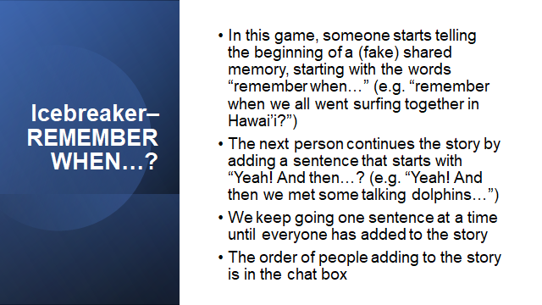
- Group discussion: Introduction Icebreaker Facilitator 20 mins

- Group discussion: Your reflections on last week’s discussions Facilitator 10 minutes

- Stories: Facilitator 10 minutes
  - Making hard decisions (ex. Melody’s experience)
  - What can happen when others make decisions for you (ex. Gary Coleman or Britney Spears)
  - Being seen as a decision-maker is important to who you are (ex. John Patrick)

- Presentation: Facilitator 20 minutes

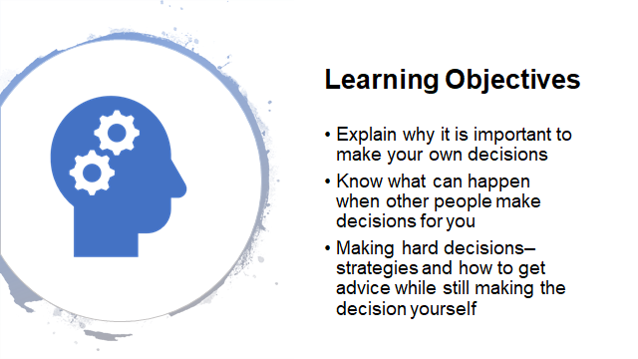

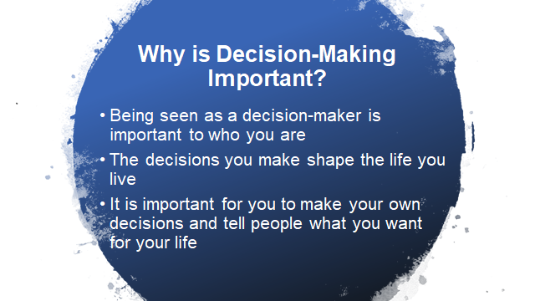

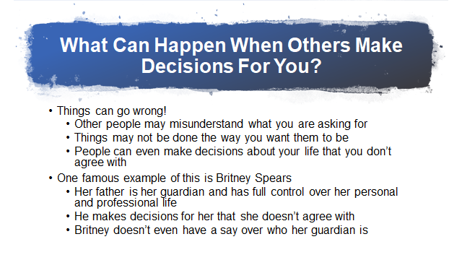

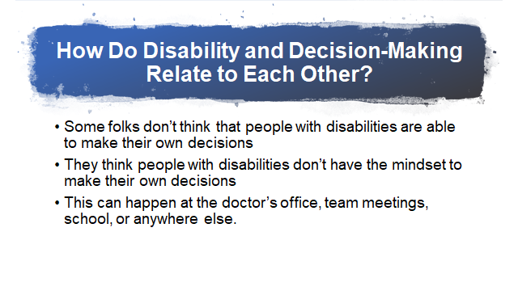

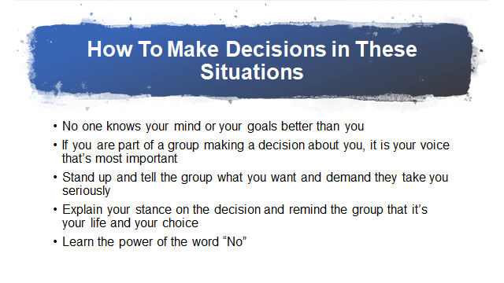

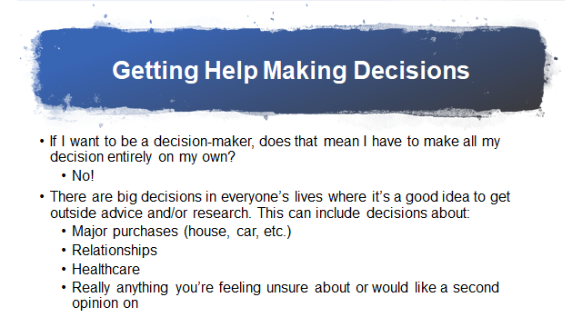

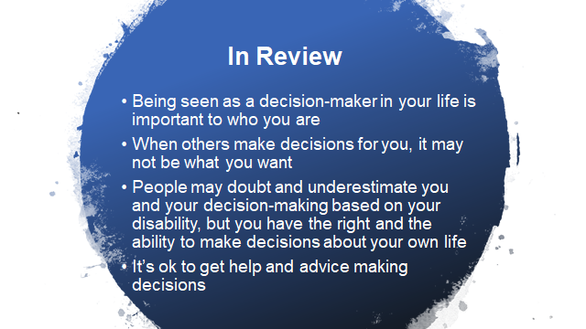
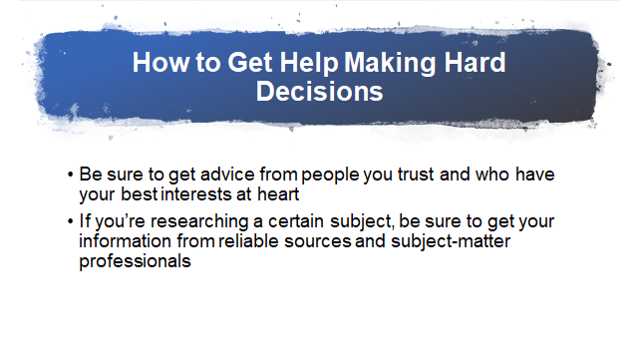
- Small Group (5 people per group) mix-matched discussion: Facilitator 30 minutes
  - What important decisions have you made?
  - How did you make it? Did you get help?
  - How would you feel if someone made it for you?

Lead | Note taker
Person 1 | Person 5
Person 2 | Person 6
Person 3 | Person 7
Person 4 | Person 8

- What’s next? Facilitator 10 minutes

What is next?

John McCarty Link to video:
https://youtu.be/5iXwzr16ELU

Step 1 Watch video

Step 2 What do you think?

1 pager on your state Guardianship laws
Step 1 read the 1 pager from your state

Step 2 what do you think? Come ready for next week to discuss your thoughts.

