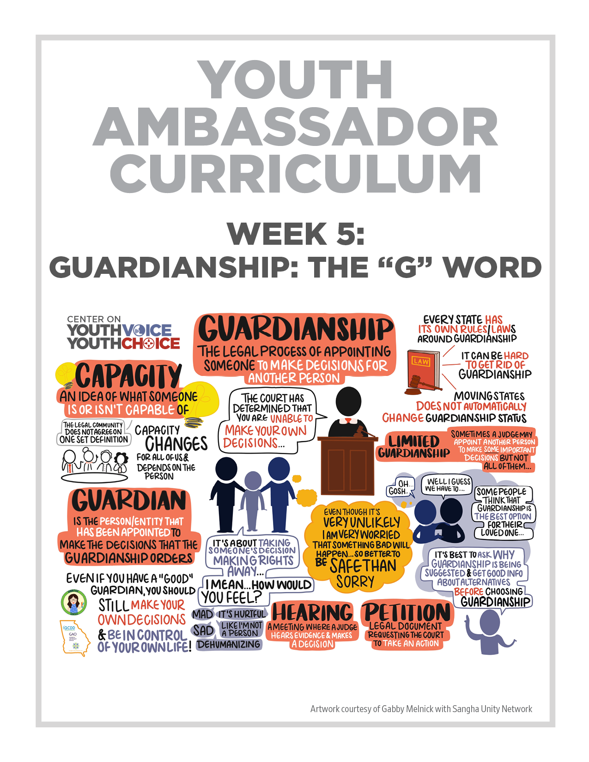
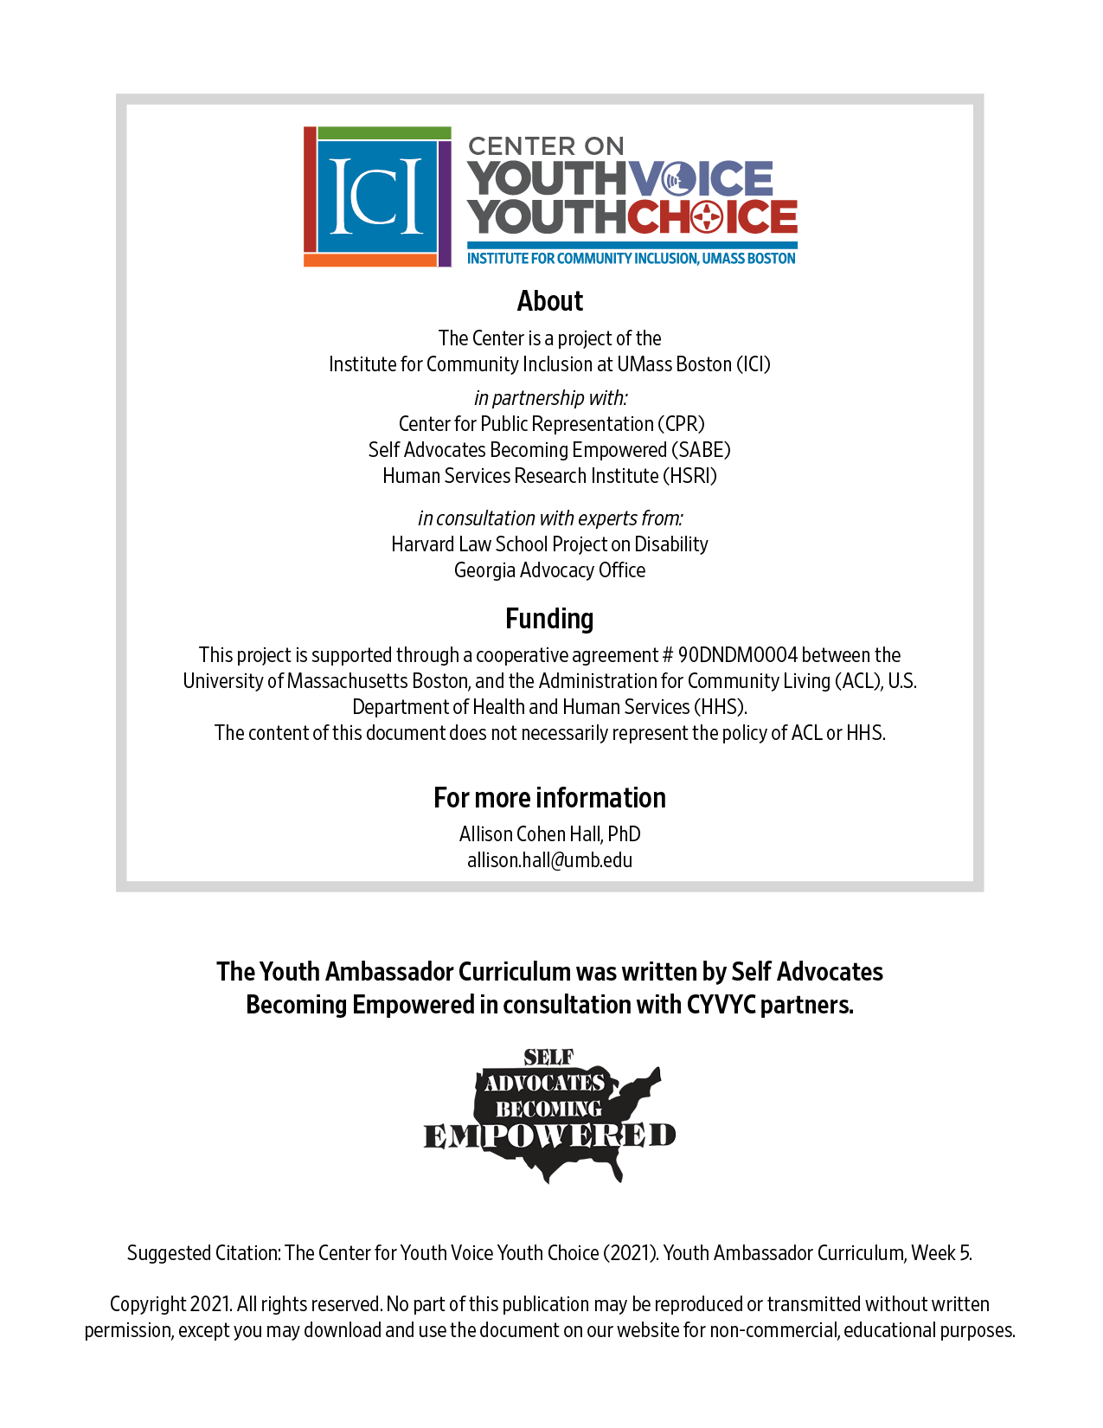

Week 5 – Guardianship The “G” Word

Week 5 – Guardianship (The “G” Word)
Learning Objectives Facilitator

Words for the week: Facilitator

Guardianship - a legal process where someone makes decisions for another person and has a big say in that person’s life

Limited Guardianship – lesser kind of guardianship. A person can make some decisions in their life.

Guardian - the person appointed by the court to make decisions on behalf of someone else.

Capacity – in legal setting, the ability for a person to make decisions about things that affect their daily life.

Petition – a piece of paper you give to the courts to ask them to do something

Hearing - to provide the opportunity for each side of a disagreement to tell their story

- Presentation: Facilitator 20 minutes
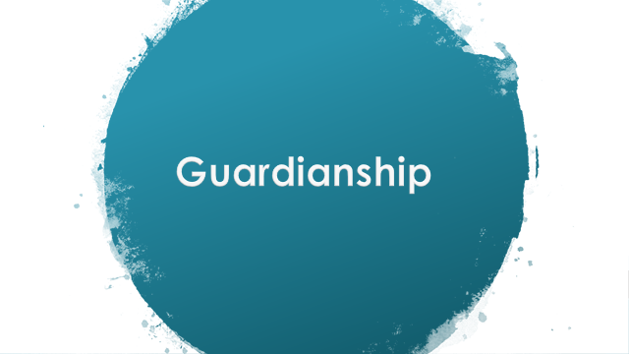

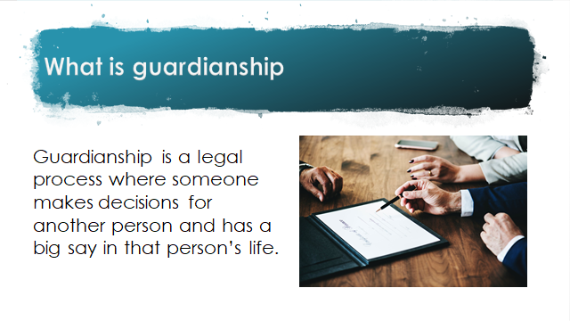
Guardianship happens in a court with a judge.
Guardians have power. Some people have guardians who are helpful. And some people do not have guardians that are. That is where people get into trouble. Even if you have a good guardian, you should try to make your own decision and control over your own life.

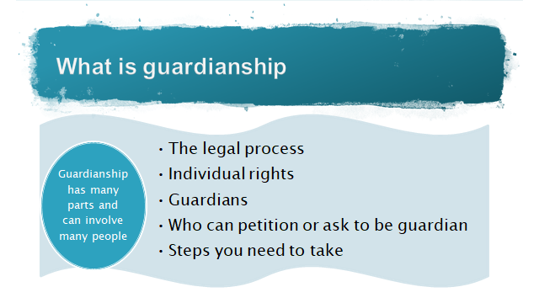
Every state has guardianship and they have different rules and what it means. Different for each person, depends on the needs such as medical and finances.
Guardianship affects people’s rights. People may or may not have chosen who their guardian is. They may not be a family member and may not have good intentions. The steps may be different, it depends on the state. It may be complex, but at the end of the day, guardianship is about taking away the decisions and rights of a person, the courts believe the person cannot make decision, and gives the rights to someone else who can make the decisions.

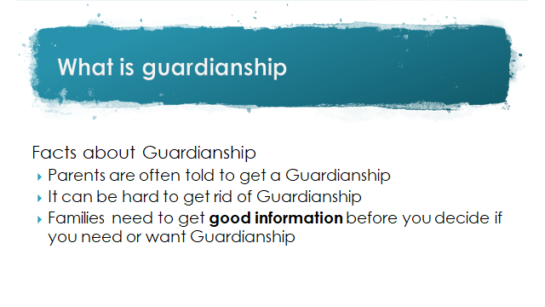
Schools, doctors, other parents who are guardians, and other family members who do not want the responsibilities, and lawyers tell families to do guardianship.

Reasons why it would be hard to get rid of a guardianship: It can be scary. Is it going to be safe to have a guardian? Some people do not know they have a guardian. Money is involved. Even if you get a lawyer or judge who thinks you don’t need a guardian, a doctor may say you definitely need a guardian.

Families need to get good information about choices. This is also called informed choice

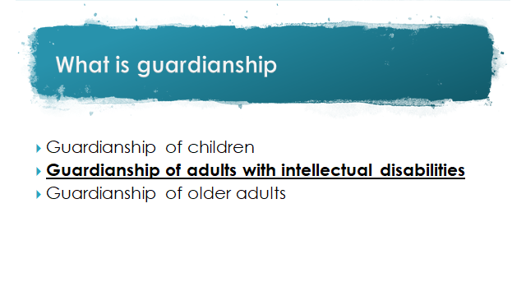

Even if you have a guardianship, we should think about…

Nothing about us, without us

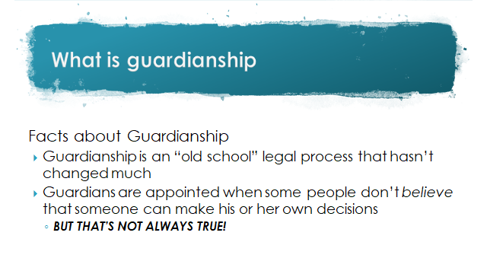
Guardianship is old as sharks and crocodiles and like institutions back in the days…

Guardianship is not always right. We now look at ways to support people, so guardianship may not be good and old fashioned.

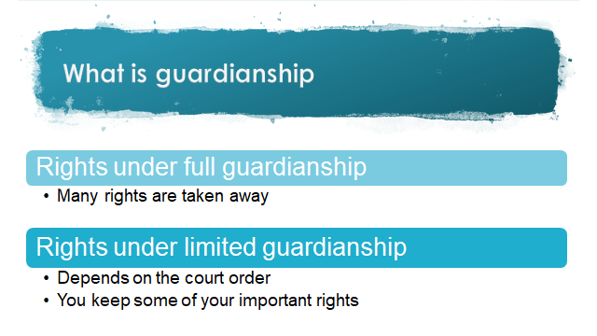

There are 2 types of guardianships full and limited. Some states call it conservatorship for limited guardianships.

Example: I just need help with my medical or money decisions
Families may benefit from these choices, support family household
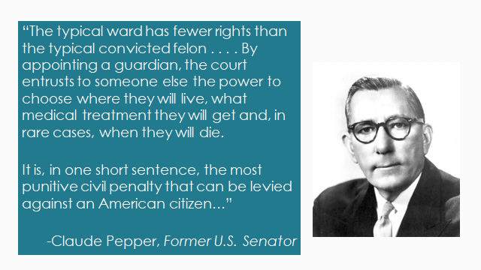

People are different and are informed about guardianship
they take it how they want.

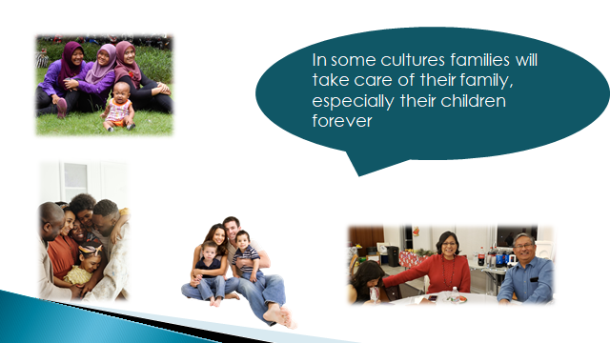

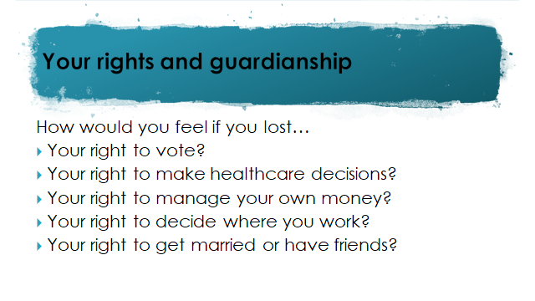

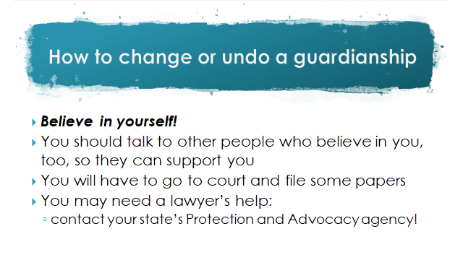
The rules for changing or undoing guardianship are different in every state.

Check your fact sheet for your state to see what they say.

There are many organizations in your state that can help change or undo your guardianship. But remember, it will take time to do it.

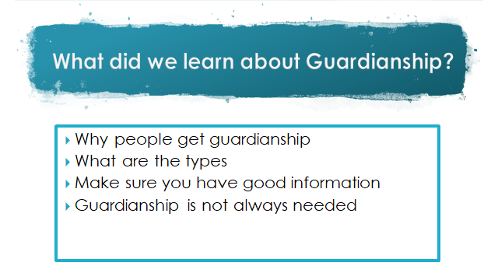

We all need support and levels of support at some point in our lives

- What is guardianship and how does it relate to old ways of thinking about disability? Refer to the state laws we are presenting to Facilitator 20 minutes

  - Who do courts appoint guardians or conservators for?
  - What kinds of decisions can guardians and conservators make?
  - Can people end their guardianships and conservatorships?
- What’s next? Facilitator 10 minutes
Watch video

John McCarty video on terminating guardianship
https://youtu.be/PmWAZpItZ6Q

Step 1 Watch video

Step 2 How can you talk about this?

Step 3 Do you have any stories in your state about people getting rights back or ending your guardianship?

- Group discussion with HSRI: 20 minutes
Checking in – How are you doing?

