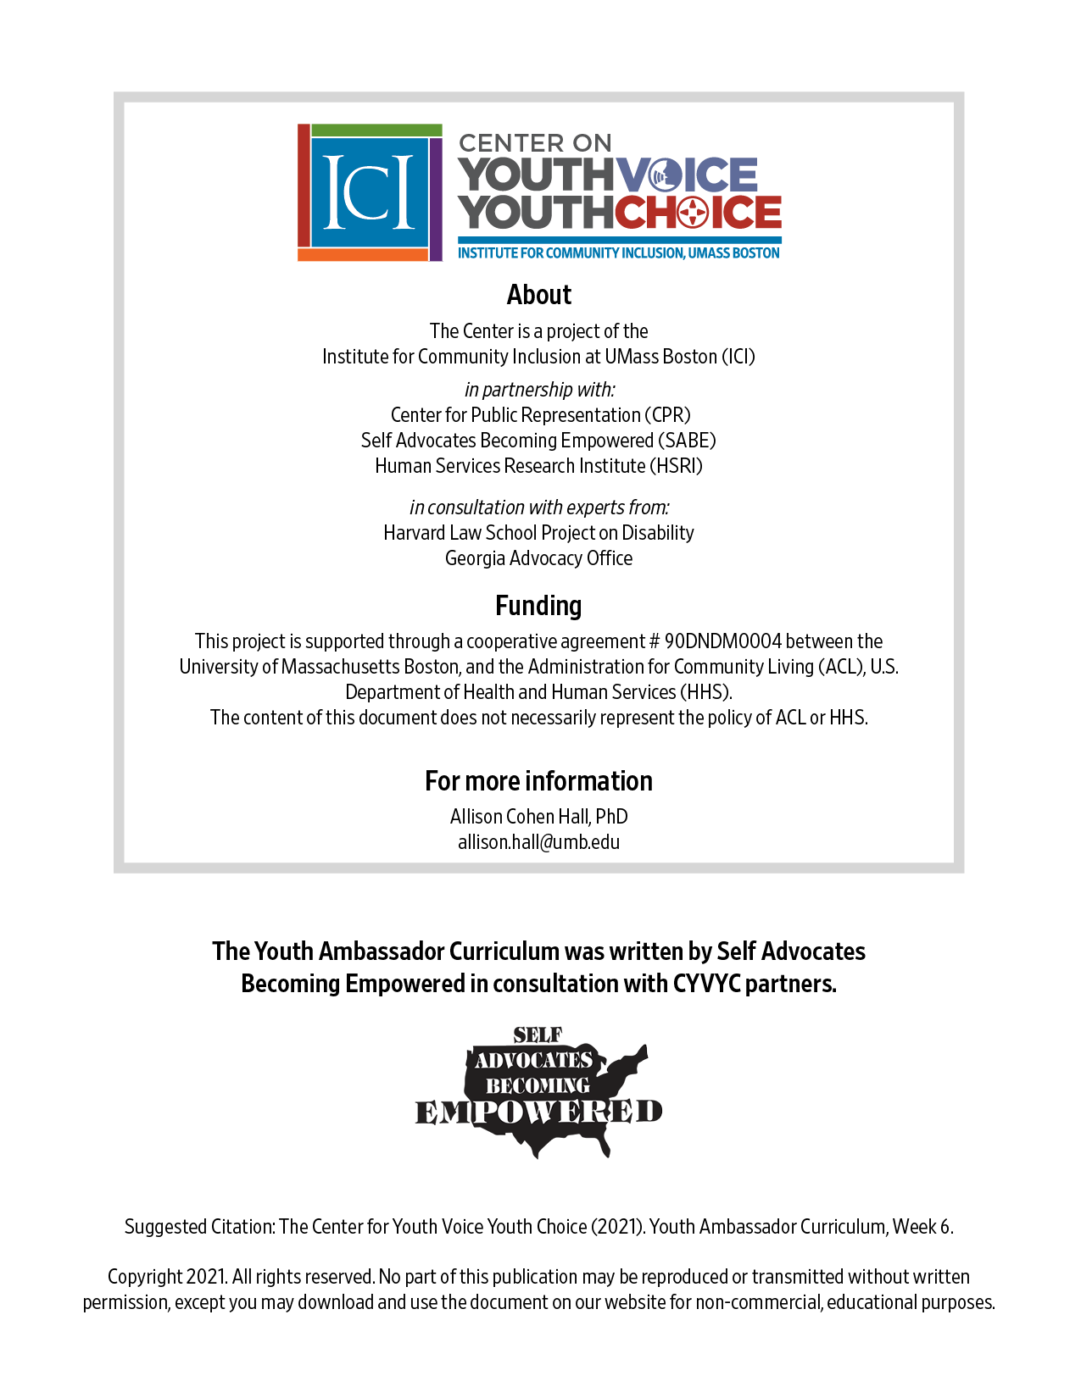

Week 6 – Guardianship Alternatives (Different Ways)

Week 6 – Guardianship Alternatives (Different Ways)
Learning Objectives Facilitator

Words for the week: Facilitator

Supported Decision-Making - people with disabilities are in charge of their life. They keep their rights and get guidance and supports from trusted people. It is all about trust and who you trust.

Supported Decision-Making Agreements – another way of saying a contract between people with disabilities and their supporters to help them to make decisions that affect their life. It says what the role of the supporter is and what is expected.

Alternatives to Guardianship – tools that are not Guardianship that people might want to use to make certain kinds of decisions about their lives. Includes such things like supported decision-making.

- Group discussion: Introduction Icebreaker Facilitator 5 minutes
Answer in the chat box
What is your favorite kind of ice cream?
- 1 Vanilla
- 2 Strawberry
- 3 Chocolate
- 4 All of the above
- 5 None of the choices, tell us what it is

- Group discussion Facilitator 20 minutes
So what is happening about Supported Decision-Making in your state?

- Presentation: Facilitator 20 minutes
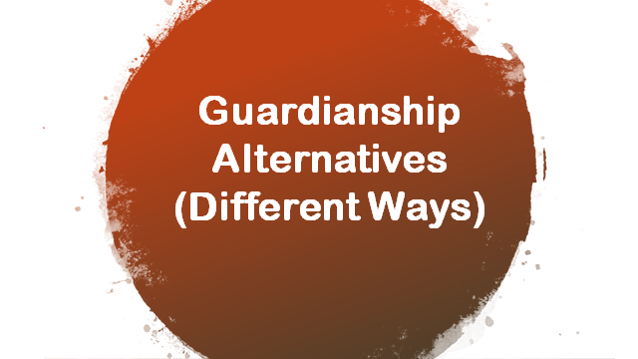

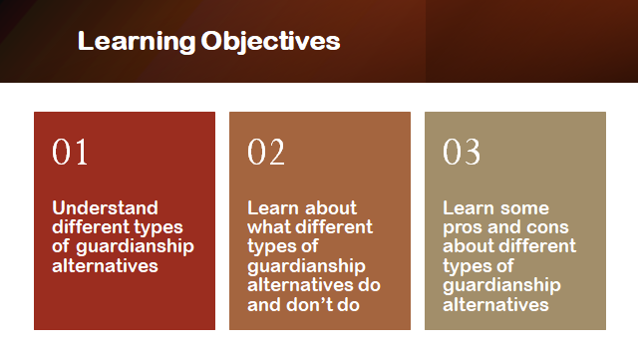

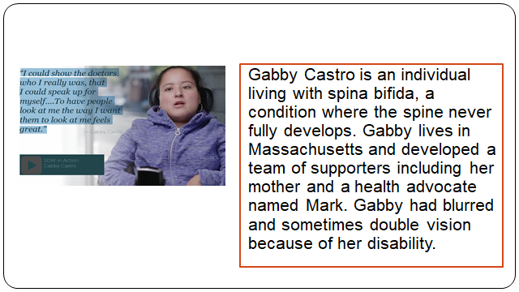

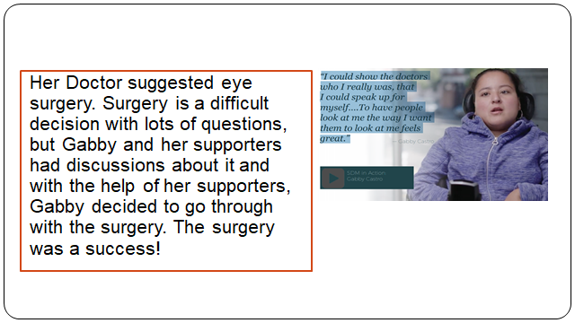
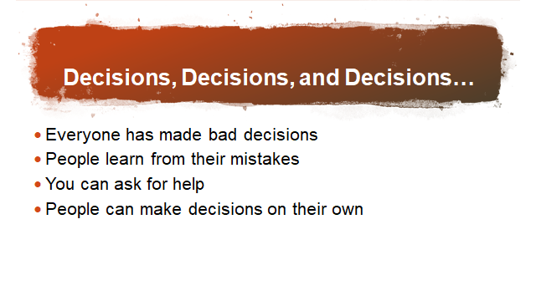

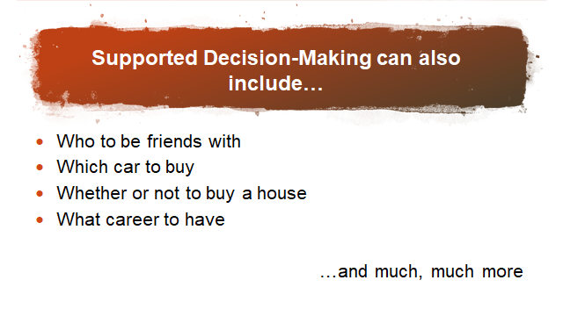
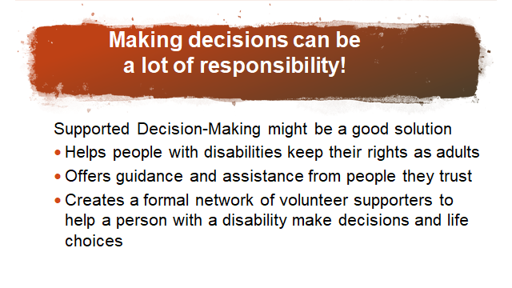

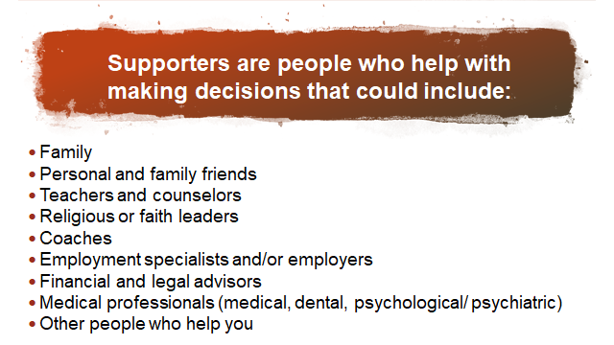

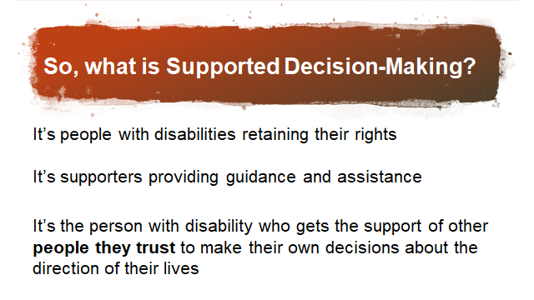

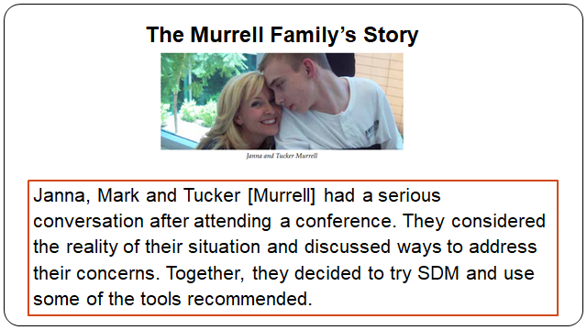

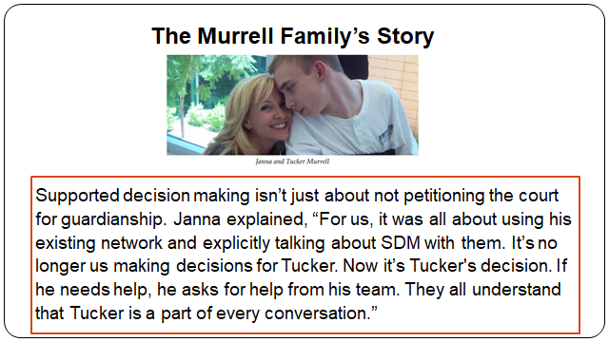

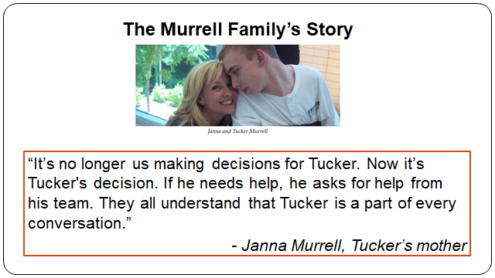

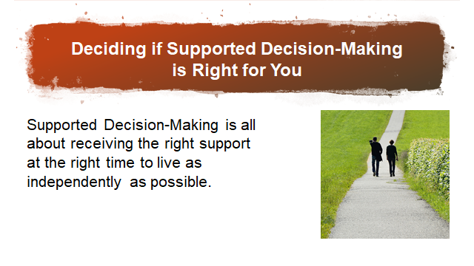

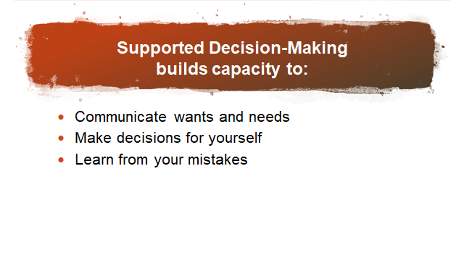

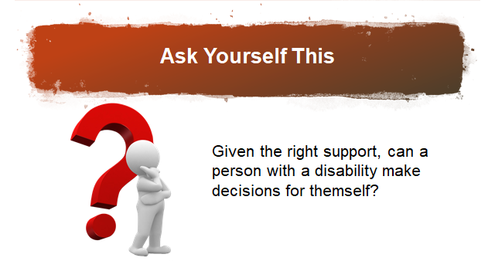

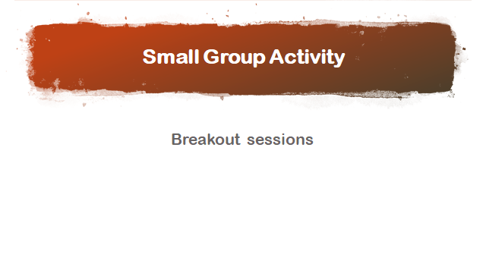
Note: ask in chat who is supporting who?

15 minutes

What kind of decisions have you made with supports?

Can you think of people you can ask for support on an important decision?

Are there certain people you may not want to ask? Why?
What are the pros and cons of making decisions with support and without support?

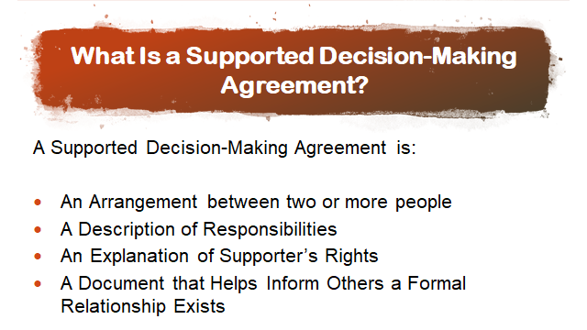
In some states, a supported decision-making agreement may not need to be recorded in court

Formal and informal documentation

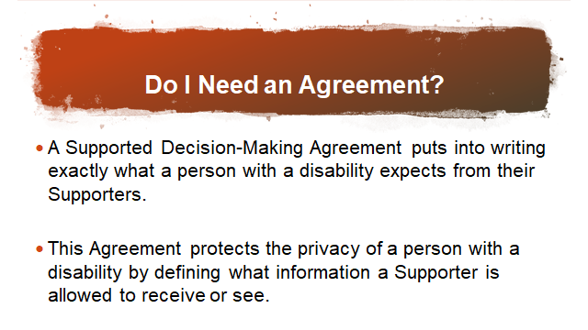

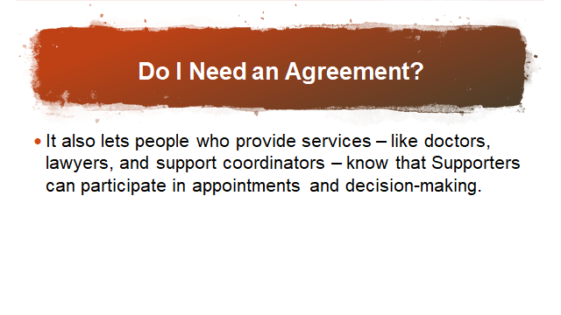

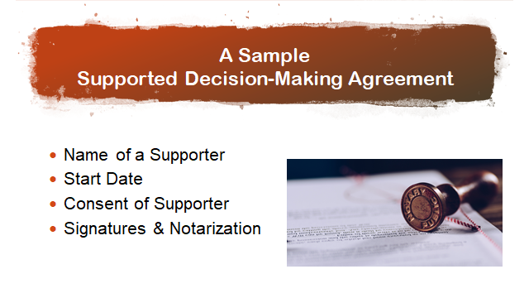

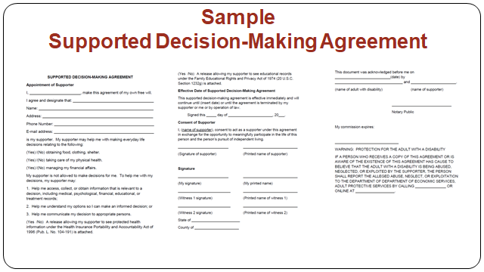

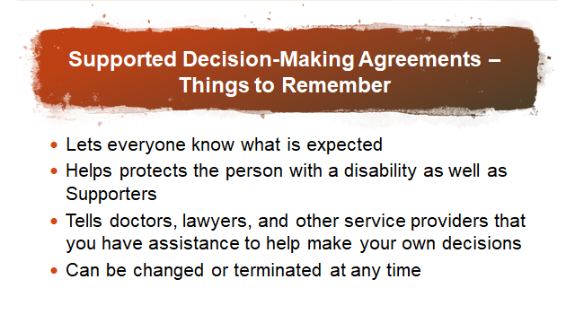

And you don’t need a guardianship

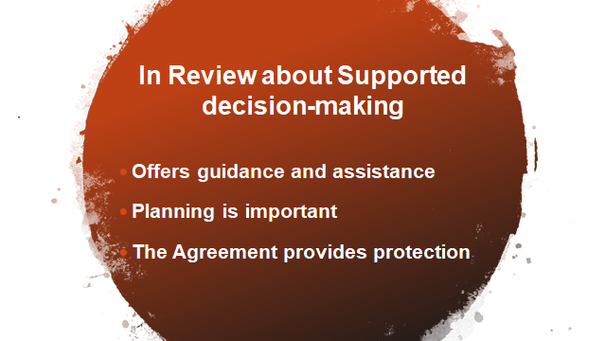

- What’s next? 10 minutes

Learn about supported decision-making and report back

Instructions needed
Step 1 research one thing about supported decision-making from your state

Step 2 share one resource about supported decision-making with the whole group on Thursday

