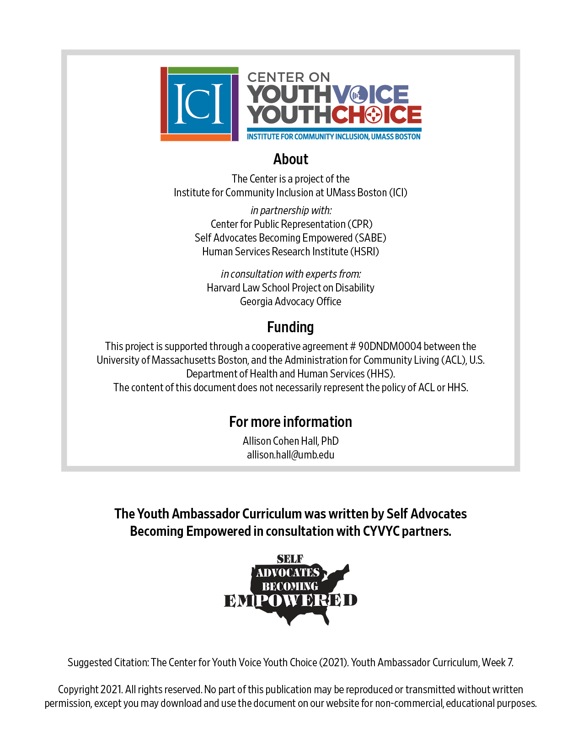

Week 7 – alternatives to Guardianship

Week 7 – Guardianship & Alternatives
Learning Objectives Facilitator

Words for the week: Facilitator

Power of Attorney - A legal document that you agree to make someone sign legal and financial matters for you.

Advance Directive - a written statement that allows you to share your goals and wishes for health care if you were not able to express them yourself.

Representative Payee - A representative payee selected to accept disability or Social Security payments for someone unable of manage their own benefits.

- Group discussion: Introduction Icebreaker Facilitator 15 minutes

Step 1 Pick a season:
Spring, Summer, Fall, Winter

Step 2 What do you like doing with family or friends during the season you picked?

- Group discussion: Share your resources on Supported Decision-Making information from your state. Facilitator 15 minutes

- Presentation: Alternatives to guardianship Facilitator 30 minutes

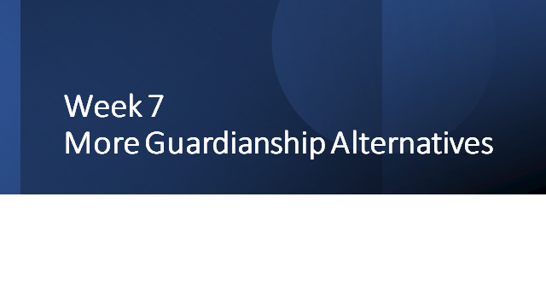

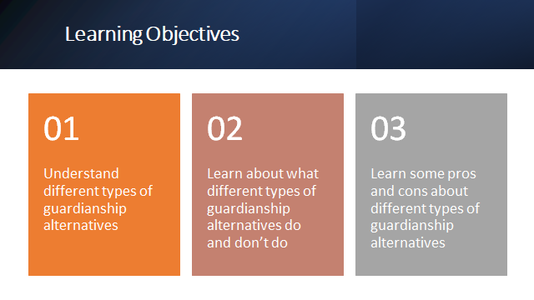

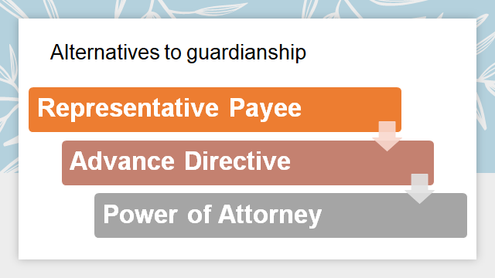

Reshma is a young woman who receives Supplemental Security Income. That means she gets payments every month from the Social Security Administration because of her disability. She is not used to keeping track of her payments. She has a parent who she trusts to help manage her benefits for her. She doesn’t want a guardianship.

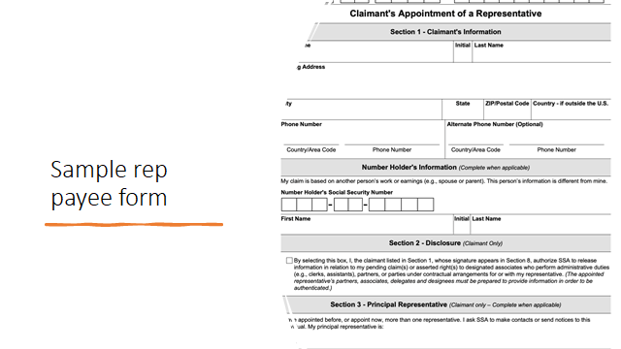

Adrienne is a young woman who sometimes has trouble understanding what her many doctors tell her. Doctors also often have a hard time understanding what she tries to tell them, too. She knows that in the future she will need some surgeries and will have to see a lot of doctors along the way. After her surgeries she’s not sure how soon she’ll get to go home to recover. She has an aunt who she trusts to help her make health care decisions when she needs help. She doesn’t want a guardian, because she feels that she can make most health care decisions on her own. But she doesn’t want her communication challenges with her doctors to get in the way of her getting the health care she needs. What guardianship alternative can she use?

Paolo is a young man who has been working for a while outside of school and he wants to get a little more independence. He wants to move out of his parents’ house so he can live on his own. He knows that means he might have to sign a lot of paperwork to get his own place to live and to pay bills and things like that. He’s confident that he can live on his own but he’s not so sure that he wants to sign a lease on his own. He has heard that sometimes those things can be tricky and he wants his first experience to go well. He has an older brother who has been living on his own for a while who’s a lawyer that he trusts to help him make decisions about contracts, money, and things like that.
He also has another concern. He just turned 18 years old and he gets special education services. Sometimes he finds his IEP meetings intimidating and doesn’t understand everything that everyone is saying. They all talk really fast! He wants to be more independent but he’s not sure of everything that the IEP says and he’d feel more comfortable if someone else signed it instead of him. He trusts his mother to advocate for him in his IEP meetings and he thinks she has done a great job.
Is there a guardianship alternative that addresses both Paolo’s concerns?

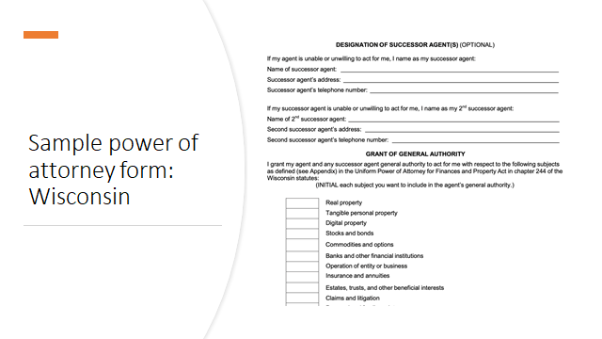

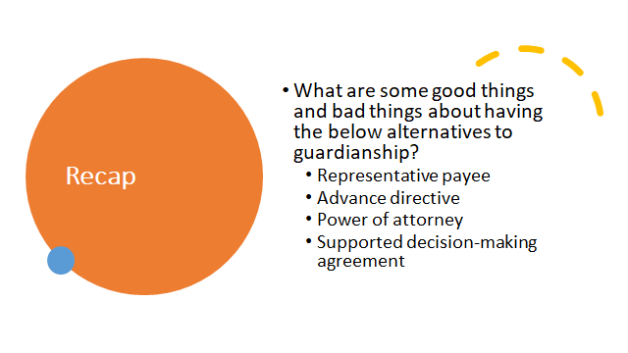

- Mix small group discussion Facilitator 20 minutes
Room | Facilitator | Note taker
1 | Person 1 | Person 4
2 | Person 2 | Person 5
3 | Person 3 | Person 6

- What’s next Facilitator 5 minutes

Step 1 Question: Which of the 5 ways we talked about would you want to use in your life?

Step 2 Question: Why or why not?

Step 3 Report back to the group next week

