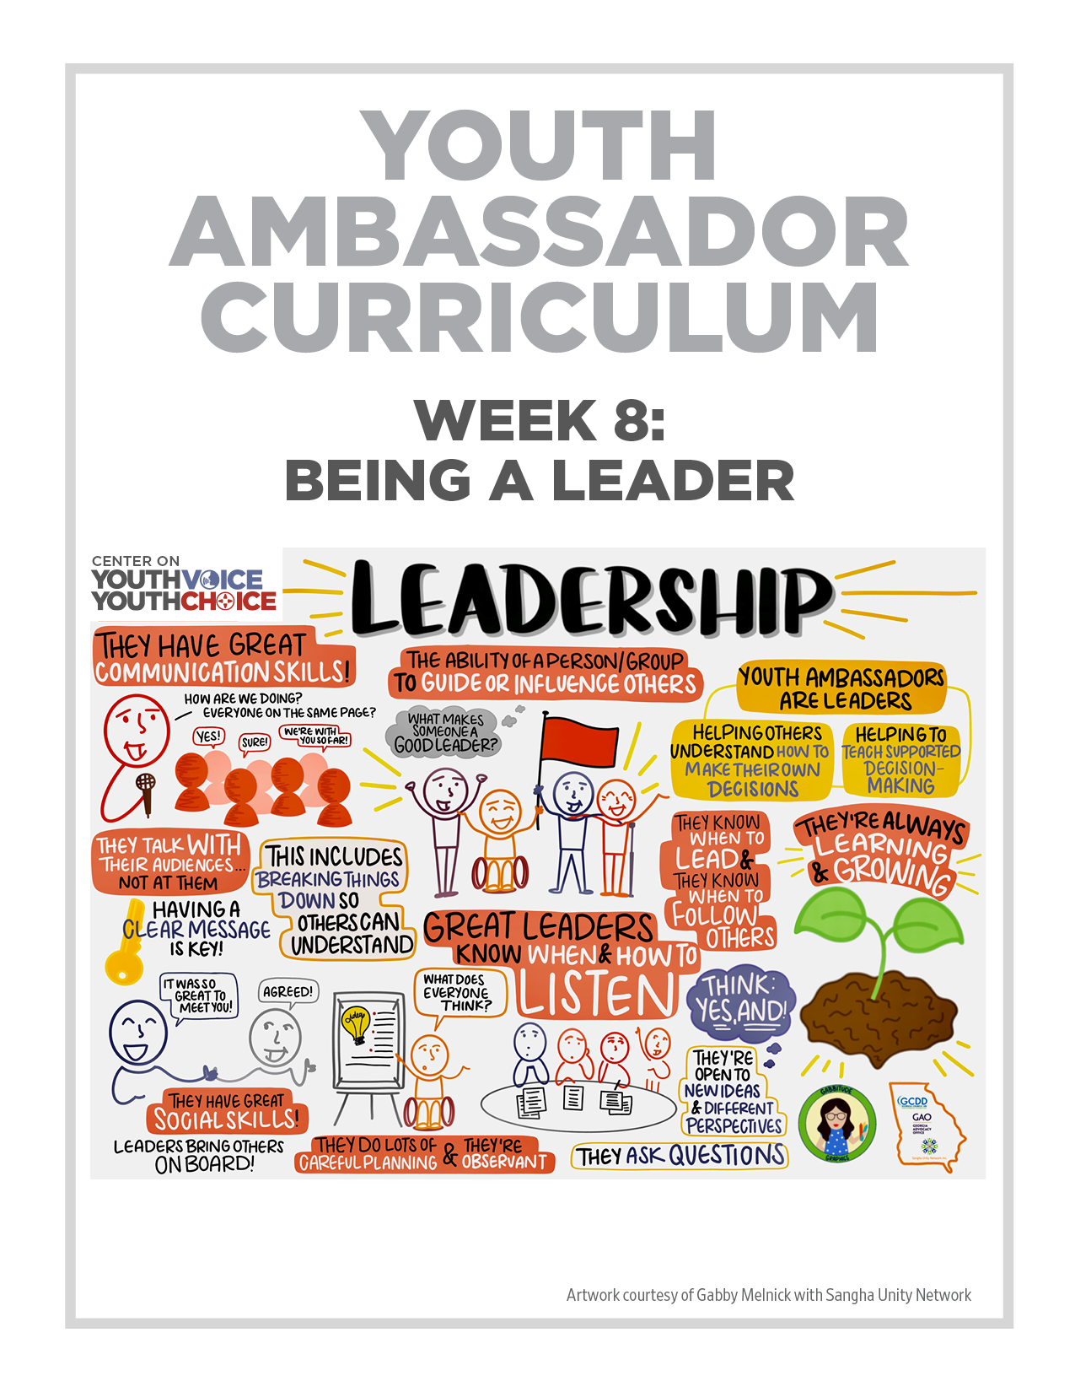
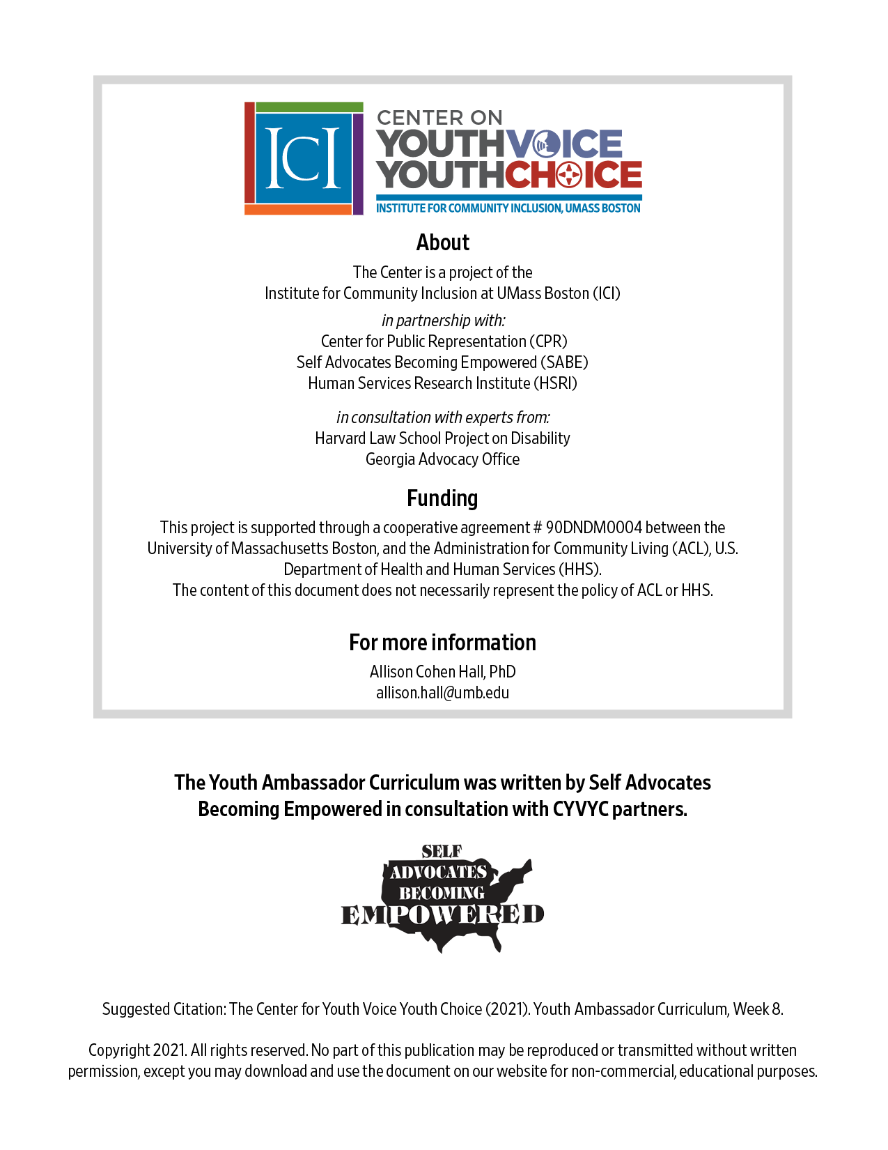

Week 8 – Being a Leader

Week 8 – Being a Leader
Learning Objectives Facilitator

Words for the week: Facilitator

Ambassador – A messenger or representative. CYVYC Youth Ambassadors are young people with intellectual and developmental disabilities (IDD).
They help people with IDD understand how to make their own decisions. They will help teach people about supported decision-making and ways to avoid guardianship

Leader - Sees more than others see, further than others and helps other people make it happen. It is a process over time and you learn along the way

Leadership - The ability of an individual or a group of individuals to influence and guide other people.

- Group discussion: Introduction Icebreaker Facilitator 30 minutes

For each one of the following, Why or why not would you like to use them in your life? Define first

- Presentation: Being a leader Facilitator 30 minutes
Big 11 ideas of a leader:

- Ambassadors are a kind of leader
- Leaders and ambassadors listen to the people they lead
- Leaders and ambassadors also know how and when to follow
- Leaders and ambassadors communicate effectively
- Leaders talk with their audiences
- Leaders and ambassadors carefully plan
- Leaders are always observing
- Leaders are always learning
- Leaders are brave, they are not afraid to fail
- Leaders are good at breaking hard stuff down
- Leaders build organizations and bring people on board

Questions:
Ask YA: Did we miss anything? Write your answer in the chat.

- Small group Activity: Share leadership experiences (successes and challenges) Facilitator 20 minutes

Example of leaders:
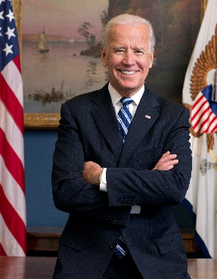
This Photo by Unknown Author is licensed under CC BY-SA
This Photo by Unknown Author is licensed under CC BY-SA

Room | Facilitator | Note Taker
1 | Person 1 | Person 4
2 | Person 2 | Person 5
3 | Person 3 | Person 6

Questions:
- What leadership experiences have you had in your life?
- What are some leaders you look up to? What are their qualities?

- What’s next? Facilitator 10 minutes
Think about creating a vision board to help you become the leader/ambassador you want to become

Step 1 - watch video entitled: “What is a vision board and how do you make one?”

https://icimedia.wistia.com/medias/yr8z0dfsuj

Step 2 – think about what you are passionate about

Step 3 - set 2-3 goals on how to get to your dreams

Step 4 - be prepared to share your ideas

