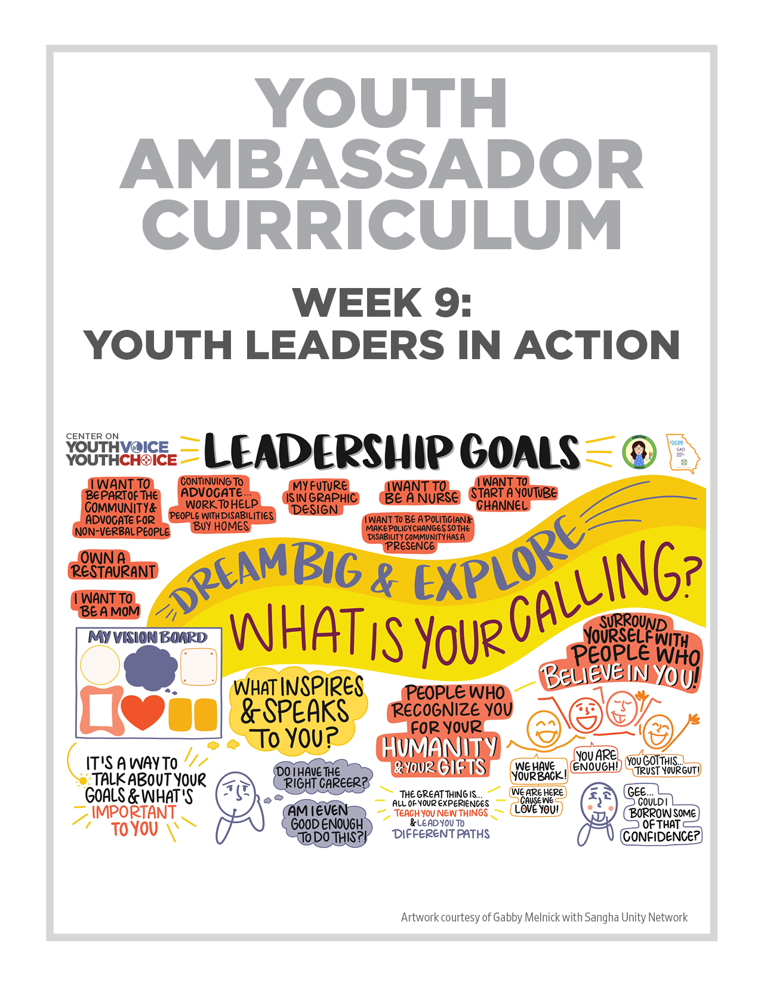
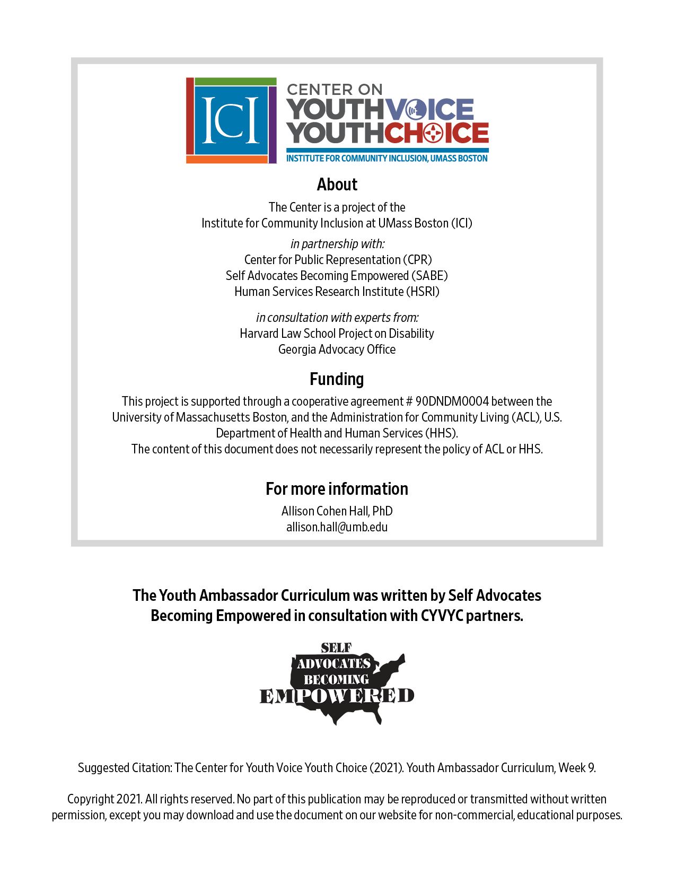

Week 9 – Youth Leaders in Action

Week 9 – Youth Leaders in Action
Learning Objectives Facilitator

Words for the week: Facilitator

Vision Board - A vision board is something you can see or touch. It’s a picture or a way to talk about your goals.

Collage – Is one way you can do a vision board.

An example of a collage is to gather together pictures, words and pressed flowers to make a work of art. ... The definition of a collage is a piece of art created by combining photos, clippings or small objects onto a surface. An example of a collage is a picture of a flower made with many pictures of friends and family.

Shadow box - A shadow box is another example. You can put things in it that is important to you. It can be objects or words.

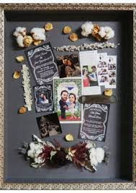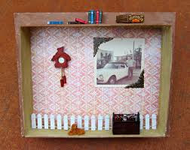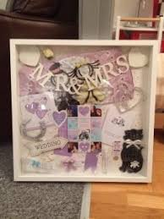

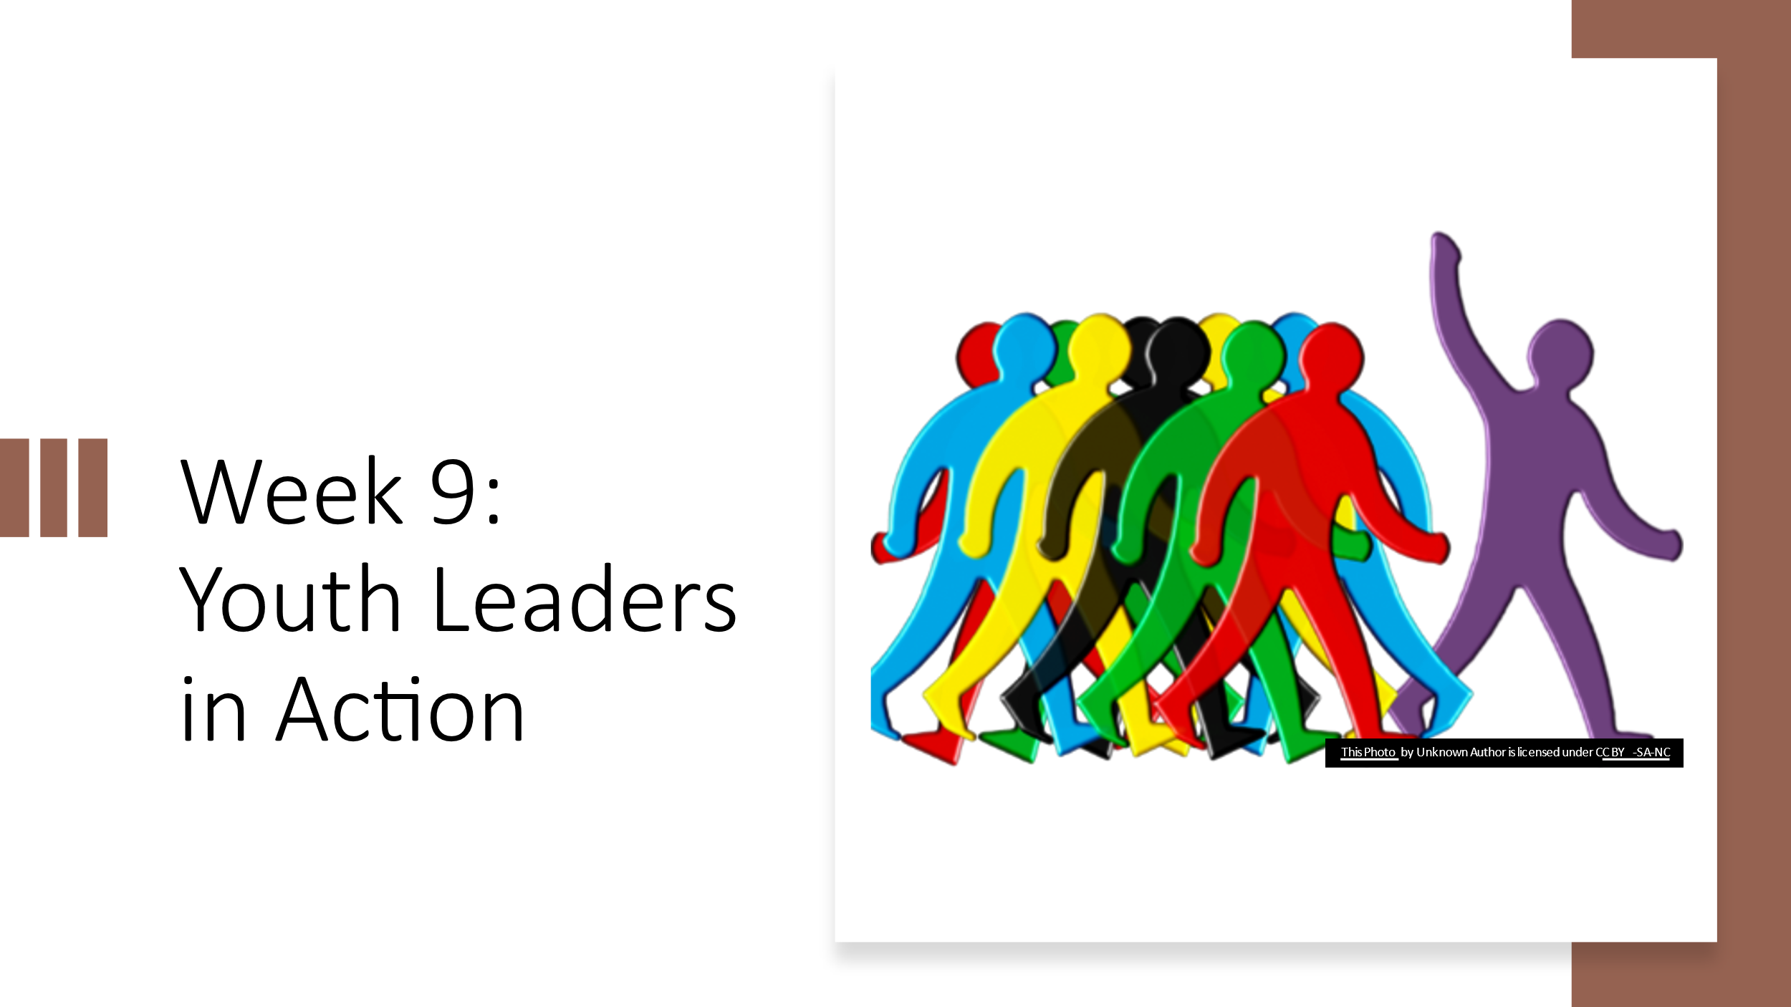

- Group discussion: Introduction Icebreaker Facilitators 20 minutes

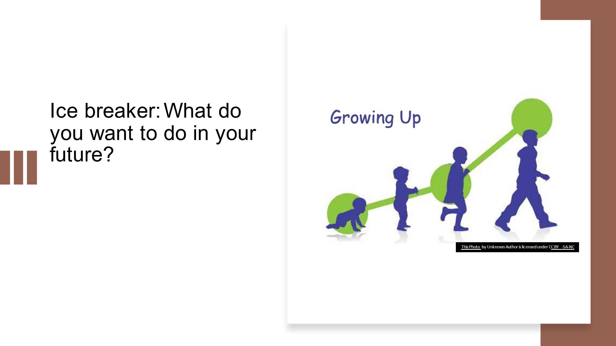
Talk about your goals and vision

Michael talks about setting your goals for the day or the weekend or next week. Taking small steps…

Questions:
What are your long-term goals in life?

Where do you see yourself in 5 years?

Where do you see yourself in 10 years?
- Small group discussions: Reflecting on their own strengths Facilitators 20 minutes
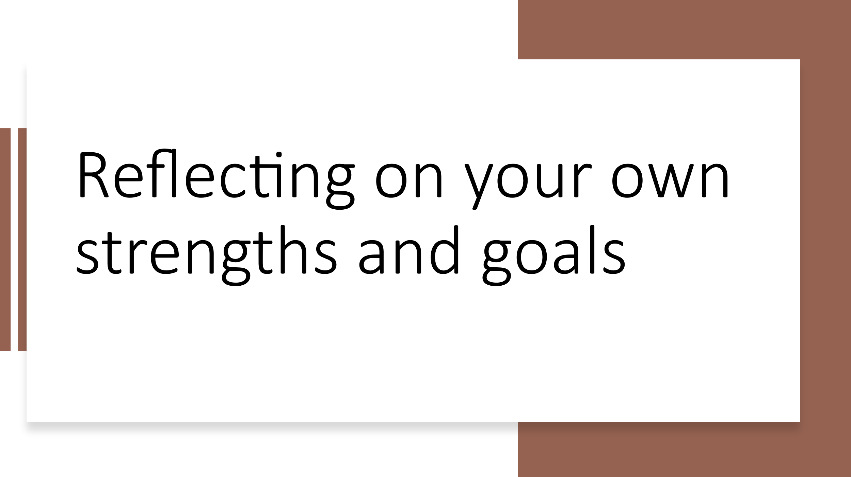

Questions:
What are you good at? Hobbies, talents, interests, experiences, or skills…

What are your leadership goals?

 | Facilitator | Note taker
1 | Person 1 | Person 4
2 | Person 2 | Person 5
3 Main | Person 3 | Person 6

- Group discussion: Your leadership vision board Facilitators 5 minutes
Share examples of vision boards

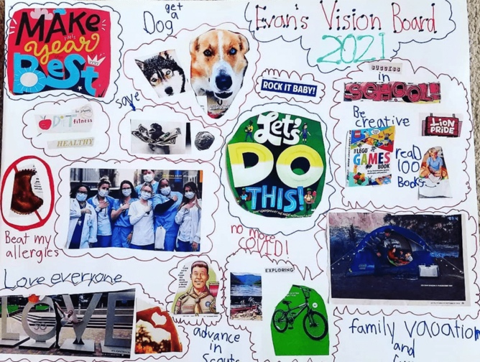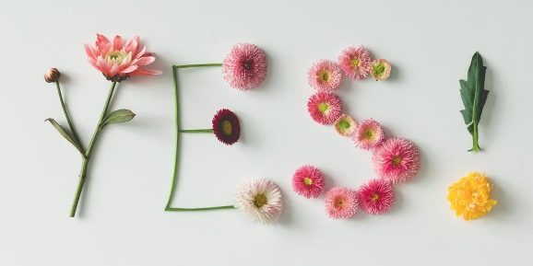

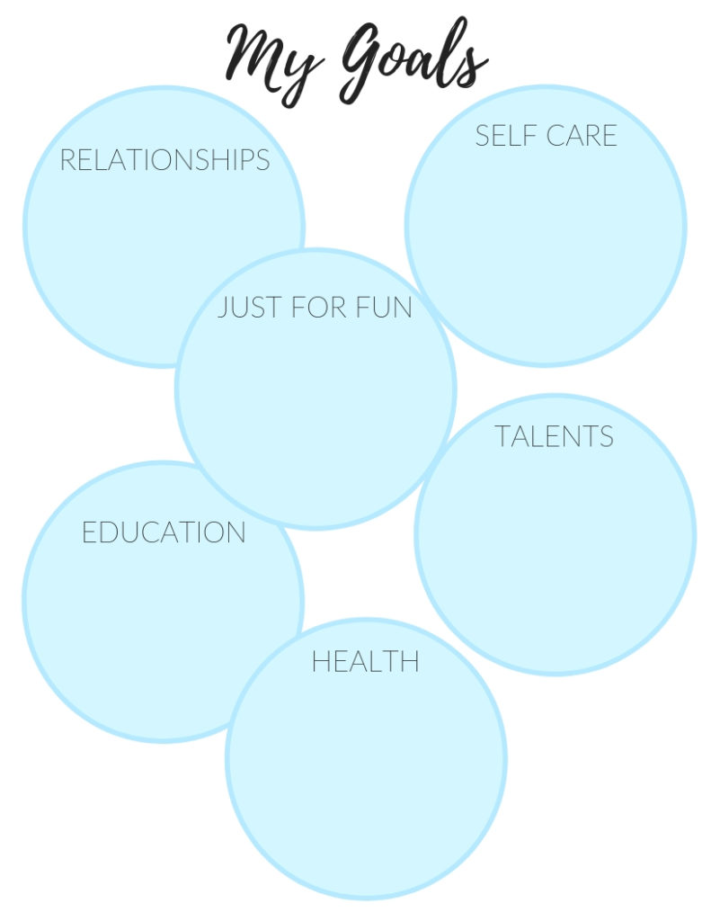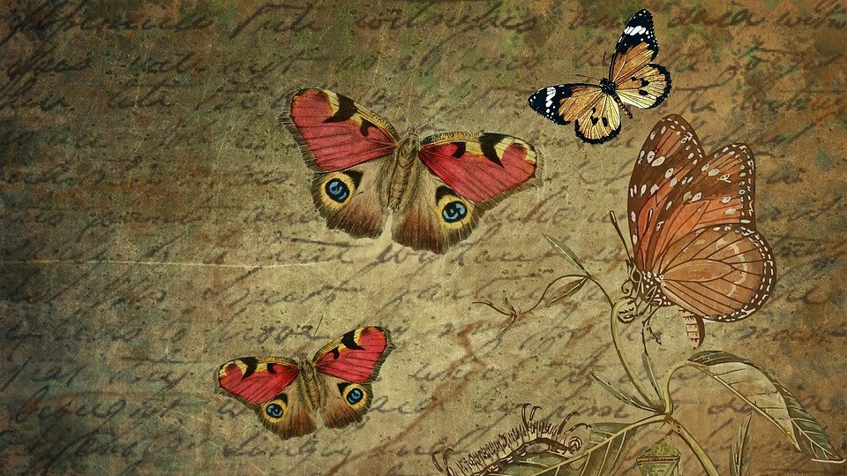
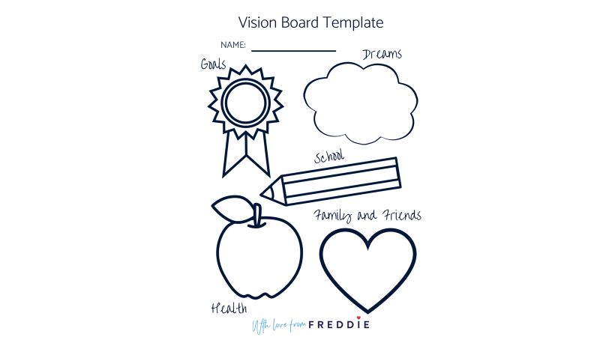

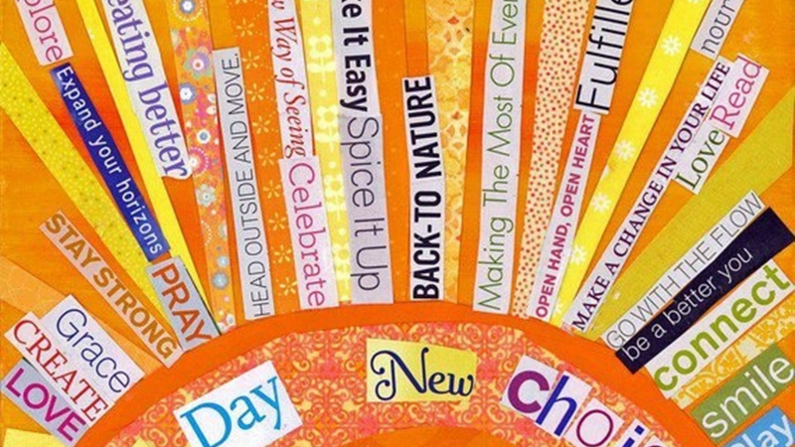

- Presentation: Melody and Michael will share their stories Juliana 15 minutes

Melody story
- Moved to Indiana in 1990 and worked at a workshop making sub-minimum wage, then worked at a grocery store bagging groceries
- Took a class in early 2000, Partners in Policy from the DD Council
- Introduced to self advocacy group by a presenter, Betty Williams
- Mentored by Betty and learned a lot
- Went to state and national conferences to present
- Became an officer for the self advocacy group
- I am a graduate of the LEND program in Indiana in 2016
- I am currently writing a book about my life
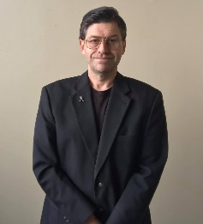
Michael story
- I started understanding who I was when I took a class in college and wrote about the “R” word
- It helped me to tell my story at the capitol when we were changing the spread the word, end the “R” word in our state
- From there I started attending advocacy conferences nationally and locally
- I have been interviewed by the news station about ending the “R” word
- I was invited by the director of the UCCEDD to be part of the LEND program
- I went back to college and have graduated from the LEND program in 2015 and for the past 5 years I am a self advocacy faculty
- This past December I was invited to apply for a position at the Disability Rights Center in Arkansas as a Disability Self Advocacy Coordinator for the Self Advocacy Network Development SAND

- Your own Vision Board Facilitator 15 minutes
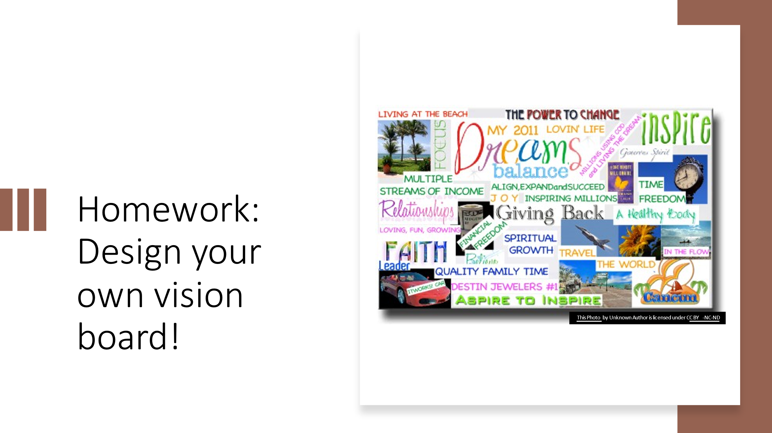

Ways to share your vision board - possible ways you can share

- What’s next? Facilitator 10 minutes

Sharing your vision boards

Next week: learning about elevator speeches.

